Processing Cases Procedures

Review for completeness

Make sure all the information is filled in on the application, the correct fee is submitted, and if a site plan is required that it meets the minimum Zoning Ordinance requirements.

If it is a site plan and it is going to the Planning Commission, verify it is submitted by the deadline date for the next meeting. Fill out the City Staff use box at the top of each application regarding date submitted, receipt #, and check #.

Enter into Zoning Orders book

After you have reviewed the application and submittal for completeness, then you will need to assign a case number. To do this you will first enter the case into the Zoning Orders book.
Location of Zoning Orders book - F:\QFILES\Zoning Orders Book\zoning orders book. The number you assign will be in this format ##-Type-Month case is being heard-Year. So, if the application is the 21st one submitted and it will be heard at the November Board of Zoning Appeals meeting, the case number will be 21-VAR-11-15. Write the case number on the application in the City Staff Use box next to File Number.

Enter into Building.net

After you assigned the case number you will then enter it into Building.net if the request deals with a parcel. For instance, street vacations and ordinance amendments will not be entered in the Building.net system. However, License/Easement Applications, Appeals, or Interpretations would be entered if they are for a property. If it is a general appeal or interpretation, or a license/easement for right-of-way then you would not enter it in.

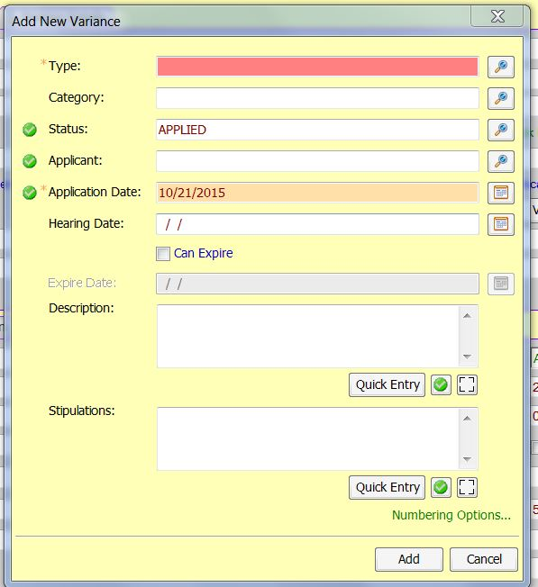
In this system, all of the applications relating to cases will be placed under what they label as “variances”. Note: The reason they used the word variances, is because this is a Building program mainly for Building Codes, and they only do variances besides permits. This is the only logical place to put all of our case files besides just variances.

You can either type in the address number, parcel number, or owner name to search for the property that you need. Once you have found the property you will follow these steps.
- Select “Add” on the toolbar, then select “Add New Variance”
- You will select the type of case. Board of Zoning Appeals, Planning Commission, Admin Review, or City Commission.
- Then you will select the Category. This will be the type of the request. i.e. Variance – Dimensional from Ordinance, Site Plan Review, or Rezoning.
- Next, you will enter the Application date. Use the date the application was submitted.
- The hearing date will be when the Board or Commission will hear the case. If it is administrative review leave this blank, as the date will be when the plan is approved.
- At this time, you can leave the description and stipulations blank.
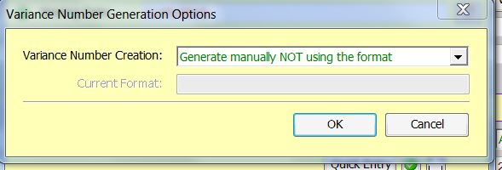
- Next click on the numbering options. Select to “Generate manually NOT using the format”. Then click OK.
- Now you will type in the case number but you must add the letter V first. i.e. V21-VAR-11-15.
- Once you have finished those steps click on the Add button.

Processing the money and creating/printing the invoice

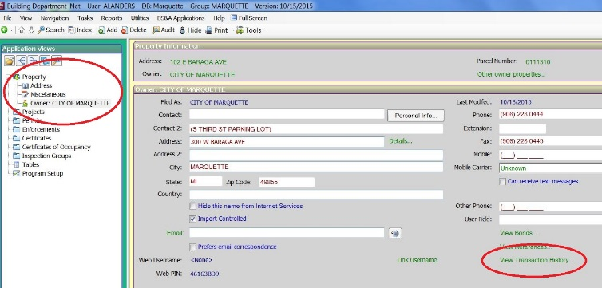
While you are still in the Building.net system you will need to create the invoice so you can submit the money to the Treasurer’s office. Warning - once you create an invoice you cannot delete the invoice so make sure you follow the step by step instructions carefully and properly.
- Click on the owner’s name under Property in the table of contents.
- Click on “View Transaction History”
- Select “Add Invoice”.
- Select “Add” for the fee. Verify you have the correct one. If not select “Remove”. If you have the correct one, then click the “Done” button.
- Now print the invoice. You will send, via interoffice mail, the front cashier in the Treasurer’s office the invoice with the check/cash.
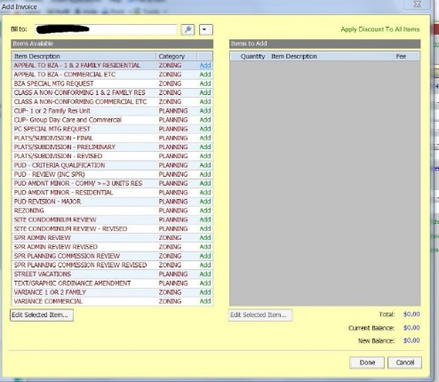
- They will send you back the receipt. Attach the receipt to the receipt book for that item that you wrote a receipt to the applicant. This helps us quickly now that the money was submitted.

Create a digital file folder and a manila one
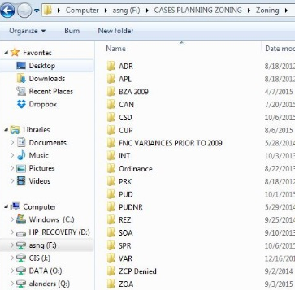
All Cases are in the following location - F:\CASES PLANNING ZONING. You will select the Planning or Zoning folder depending on the case type. To the left, you see several acronyms. To know what each one means, see the “Index explanation for case acronyms”. This document is in both the Planning and Zoning Folder.

Once you are in the folder for the case type you will create a new folder and rename it with the case name and the address, or case name and name of the project.

Next, you will need to create a manila folder for the case. Please look at the previous case to know which tab was used so you can select the next one. For instance, if the previous case used the left tab you would select the middle tab. Please do this so everything is organized and easier to see.

How to process each case type

Site Plan Review (SPR)

After you entered the case into the Zoning Orders book, Building.Net, processed the money, and created a digital and manila file you will follow the next steps.

Staff Checklist to accept or deny a site plan

Once you receive a site plan review application, site plans, and the fee.

Use the form CITY OF MARQUETTE COMMUNITY DEVELOPMENT DEPARTMENT - STAFF SITE PLAN REVIEW CHECKLIST
- Location - F:\Community Development internal forms\site plan review forms

If the plan is accepted then you route it to the other dept. Go to City Development Review Team Procedure step.

If the plan is denied, then you need to write a letter detailing all the minimum required information that is missing. As there is no SPR case number yet, you will use the template in the following folder:

- F:\CASES PLANNING ZONING\Zoning\SPR\templates for denying site plan if there is no SPR case number

City Development Review Team (CDRT) Procedure

If the plan is accepted as it meets all the required items, then stamp in the plan with the received date. Then send to other departments.
- PC Review - 12 copies of site plan
  - 9 – Planning Commission
- 1 – Police: Cpt. Mike Laurila (ask for the site plan back when finished)
- 1 – Fire: Cpt. Thomas Dunleavy
- 1 – Engineering: Keith Whittington
- 1 – DPW: Scott Cambensy (ask for the site plan back when finished)
- 1 – Planning/Zoning
- Administrative Review – 3 copies of site plan
- 1 – Fire: Cpt. Thomas Dunleavy
- 1 – Eng: Keith Whittington
    - If utilities are involved then send to Scott Cambensy (DPW) also, and ask for the site plan back when finished
- 1 – Planning/Zoning

When send to Police, Fire, ENG, PW
- Fill out the site plan city staff use box and copy the SPR application and any other support materials submitted. Make sure you have a copy for each person.
- Fill out the Site Plan and ZCP Routing Form
- location: F:\Community Development internal forms\Routing forms
  - Designate meeting time and place for City Development Review Team
    - If you need to have one (NOTE: For smaller projects you do not need to have a meeting).
    - Use City Calendar and reserve a meeting room and invite the CDRT Committee
    - Send e-mail out to the CDRT
  - MAKE SURE you type the deadline for comments to be 5 business days after you send it (usually the next Friday of the submittal week). If you do not have a meeting tell them when you need the comments by, and if you are having a meeting then mark it on the routing form under Planning Commission.
- Put the routing form and application, etc. in an interoffice envelope or roll up with the site plan
- Then deliver DPW and Engineering their site plan, and place the other depts. in our interoffice outgoing box.

Planning/Zoning Review of Site Plan

Use your form “Zoning reminder form for ord requirements”
- location: F:\Community Development internal forms\site plan review forms
- Once done with review write memo to architect/engineer that drew up plans.
  - Keep initialed original in file
  - Make 10 copies for CDRT meeting (if you have one)
  - If no CDRT meeting, e-mail your comments and the rest of the staff comments to the architect/engineer. If this goes to the Planning Commission write the deadline date of when you need their narrative response.

Planning Commission additional items

If this goes to the Planning Commission then create your staff report, scan all the documents submitted by the applicant, and create your attachments to the staff report. You can review an old case to see all of the items. Combine all your documents and send to your supervisor for review. Once they give you the go ahead combine the final documents and place in the Planning Commission E-agenda folder for that meeting date.

Attaching cases to building.net

After the Planning Commission meeting or admin review is finished, you will need to attach the case documents to building.net.

Under the “variance” case you had set up, select add external documents and you will add the case documents. i.e. 01-SPR-01-18 combined.pdf.

Create decision letter in building.net

Use the Building Department.Net program, and templates have already been created. Select the one that pertains to your request. Make sure you fill in the request and stipulations tabs before you add the letter to this case.

Under the “variance” case you had set up, select add “Write Letter”, then select the type of decision letter you need.

Send decision letter to the applicant, explain any additional items needed, if any, and Zoning Compliance Permit

Send the Decision Letter to the applicant if their case was heard by the Planning Commission. Most of the time we e-mail these now, and make sure you include any additional items that are needed, like revised site plan to meet staff comments or a Zoning Compliance Permit application if they did not submit it with the site plan review application. Remember the fee for the Zoning Compliance Permit application was included with the Site Plan Review fee.

If it was administrative review, and they have meet all staff comments with their revised plan or their original site plan meets the City Codes and Ordinances, then ask Engineering and Fire Dept. for the Zoning Compliance Permit signature sheet.

Zoning Compliance Permit
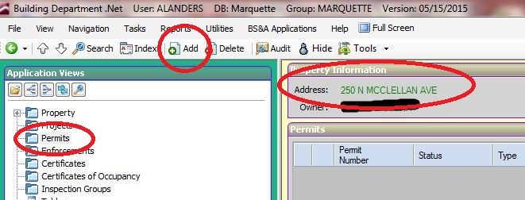
Enter the permit into the Building.Net database.

- Get to the parcel for the application
- Once there select Add
- Select “Add New Permit” then click OK button
- Select “Zoning Compliance Permit” then click the OK button
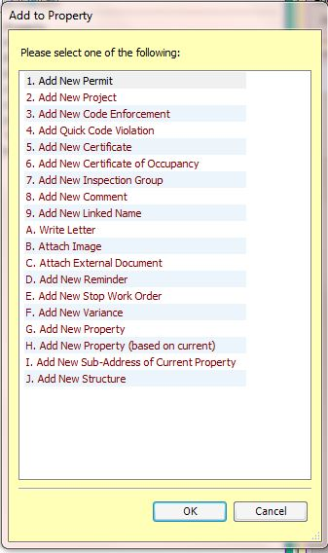

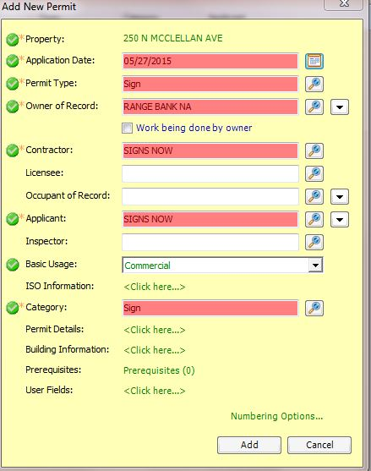

- Select date for when submitted
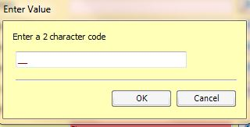
- Select type
- A prompt will ask you to enter a number. You will enter the month that the permit was submitted. i.e. May would be “05”, June would be “06”, etc.
- Invoice will pop up, close it, as the fee was included in the Site Plan Review fee.

Sign off on Permit and Enter Permit info in Building.Net

- Type in the request in the “Work Description” box.
  - i.e. 12 ft x 29 ft attached deck
- Type in the stipulations box your approval or denial statement.
  - i.e. Approval for a 12-ft x 12-ft attached deck per information provided in the application and with the location per attached sketch.
  - i.e. Denied for… as it does not meet section… of the…
    - Make sure you follow the exact guidelines on how the ordinance states you deny a permit.
- Enter date approved, this will issue the permit in the system.

Note: Make sure date applied is the date submitted or the date when you received a completed permit, not the date you entered in the permit.

Now you need to enter the approval information on the permit.
- Fill in any missing info in the application that you received from the applicant.
- Fill in the “City Staff Use” box.
  - Write the File # on the permit and the Parcel #.
  - Enter your approval statement.
  - Fill out your signature, title, date and initial the approval or denial.
  - Add the Engineering and Fire Dept. signature pages

Scan the permit

Use the 7220 Xerox to scan and rename the documents. Under the document name in the copy machine type the PIN, permit #, request (if ZCP, Fences and signs), and the date.
- i.e. 0590780 50-SGN-07-15 5-28-15
- i.e. 0590780 35-FNC-07-15 5-28-15
- i.e. 0590780 90-ZCP-07-15 shed 5-28-15

NOTE: If you do not wish to do this at the copier then when you download your scan and just rename it as stated above.

Send to County Building Codes

Send the permits that the County will need. i.e. decks, garages, porches, new homes, commercial projects (Site Plan Review)
- Jen Esides <jesides@mqtco.org>
- Becky Morrison <bmorrison@mqtco.org>

Call owner/applicant

Call the owner/applicant and let them know you have e-mailed them the approved permit or ask them how they would like to receive it if there is no e-mail address.
- They can pick up at the office;
- You could snail mail it to them;
- Or they could give you their e-mail address and you can send it that way.

Enter into Zoning Orders book

After you have received the assigned number from Building.net and approved or denied the permit, fill out the permit information in the Zoning Orders book.

Location of the Access database:
F:\QFILES\Zoning Orders Book

Once you open the Zoning Orders book, you will select the table that correlates to the permit.

- SPR is for the Site Plan Review case (this will already be there but was marked as pending, you will now mark approved)
- ZCP starting Dec of 2008 is for Zoning Compliance Permit

Attach to building.net

Attach the zoning compliance permit .pdf under the Permit in building.net.

Right click on the Permit and then select add external documents. Select the scanned Zoning Compliance Permit and click add.

