Michigan Certified Local Government
Grant Application

Grant Application Form Instructions:
  - Use the most current Grant Application Form version.
  - Complete this form electronically then print your form, sign, and submit with the required Exhibits.
  - Complete the entire form.

PROJECT INFORMATION
Grant Project Name:
Property Name:
Historic Designation:

Provide the name of the resource individually listed in the National Register of Historic Places OR a National Historic Landmark OR if the resource is listed in the nomination as a contributing resource provide the name of the National Register listed District.
Property Owner Name:
Telephone Number: | Mobile Telephone Number:
Email Address:
Property Street Address:
City, State: | Zip Code:
APPLICANT INFORMATION
Certified Local Government:

Grant Recipient Name:

This must be an authorized CLG organization in good standing with SHPO.
Federal ID Number:
DUNS Number:

The Federal Funding Accountability and Transparency Act, P.L. 109-282, as amended by section 6202(a) of P.L. 110-252, Subaward Reporting System requires the SHPO to utilize the DUNs Number to report first-tier subaward federal contracts and grants.
Certified Local Government Street Address:
City, State: | Zip Code:
Project Coordinator Name:

This individual must have complete knowledge of the day-to-day activities with the proposed grant-funded work.

Telephone Number: | Mobile Telephone Number:
Email Address:
Project Coordinator Street Address:
City, State: | Zip Code:
CLG Sponsorship Applicant Information (if applicable)
Nonprofit or Other Public Entity:

Federal ID Number:
DUNS Number:

The Federal Funding Accountability and Transparency Act, P.L. 109-282, as amended by section 6202(a) of P.L. 110-252, Subaward Reporting System requires the SHPO to utilize the DUNs Number to report first-tier subaward federal contracts and grants.
Nonprofit or Other Public Entity Contact Name:

Telephone Number: | Mobile Telephone Number:
Email Address:
Street Address:
City, State: | Zip Code:
CLG LEGISLATIVE INFORMATION

This information is used to contact your elected officials if a grant is awarded.

U.S. Senator Name: | U.S. Senator Name:
U.S. Congressional District Number:

Name of Congressman or Congresswoman:
State Senate District Number:

Name of State Senator:
State House of Representative District Number:

Name of State Representative:

SCOPE OF WORK

- On the following page describe in detail the reason the project is needed and what will be produced as a result of the project.
- How will this project benefit the resource and the community and how will the project connect with other community revitalization or economic development initiatives and planning efforts?
- Is the resource threatened by damage or destruction? If yes, please describe. Is this threat imminent (1-2 years, 3-4 years)? How will the project stabilize and/or enable continued use of the resource?
- Document how the project is being undertaken in association with one or more of Michigan’s Historic Preservation Goals identified by the SHPO in Michigan’s Historic Preservation Plan.

Rehabilitation Planning Projects
- Planning projects can include plans and specifications, Historic Structures Reports, Rehabilitation Master Plans, Condition Assessment Reports, feasibility studies, façade improvement plans, marketing studies, etc.
- Acknowledge in your grant application that any consultants hired as part of the grant project work will meet National Park Service 36 CFR 61 professional qualifications. Architectural consultants to be hired must meet the federal standards for Historical Architect listed below:
- All consultants must demonstrate that they meet or exceed the professional qualifications for “Historic Architecture” as stated in 36 CFR Part 61.
- The minimum professional qualifications for a Historical Architect are a professional degree in architecture or a state license to practice architecture, plus one of the following: (1) at least one year of graduate study in architectural preservation; or (2) at least one year of full-time professional experience on preservation projects. Such graduate study or experience shall include detailed investigations of historic structures, preparation of historic structures research reports, and preparation of plans and specifications for preservation projects.

Rehabilitation Projects
- Describe the work that will be completed as a part of the proposed grant project. The description must provide a complete explanation of the existing conditions and the work to be performed. The description should clearly illustrate all materials, methods and techniques within the provided budget, to be used for the rehabilitation project.
- If possible, include a vendor quotation for the work/services to be completed. Any historic materials to be removed and disposed of should be clearly identified. This work description will complement the required photographs to give a complete accounting of the proposed rehabilitation work.
- Plans and specifications must be submitted with the application for rehabilitation work and approved by SHPO. All plans and specifications and project work must meet the Secretary of the Interior’s Standards for Rehabilitation.
- If you do not have plans and specifications or you desire a complete building assessment with priorities and estimates of cost, you may wish to apply for a planning grant to prepare them.

GRANT FUNDING REQUEST
CLG Grant Funding Request:  Minimum of $10,000 | Total Project Amount:
Source of Total Project Amount (City, Nonprofit, etc.):
Total Project Amount Kind (Cash, In-Kind Services, etc.):
PROJECT BUDGET

All grant funds are paid on an EXPENSE REIMBURSEMENT basis only. The grantee must have funds available for expenditure amounting to 100 percent of the project cost at the time of a grant application submittal. The grantee will be reimbursed for eligible expenses incurred (up to the grant amount) at the end of the grant process. Federal funds, excluding Federal Community Development Block Grant (CDBG) funds, are not allowable as CLG grant project funding.

The SHPO will review and may make changes to the budget line items as submitted in the application. The final budget approved by the SHPO will become an attachment to the grant agreement. Allowable costs are listed below:

Allowable Work Items
- Paid Staff Time and In-Kind Services: Compensation for project personnel during the project period including wages, salaries, and supplementary compensation and benefits are allowable costs, but additional materials must be submitted with the CLG grant application. Project personnel must demonstrate that they meet or exceed the professional requirements as stated in 36 CFR Part 61.
    - Fringe benefits for paid or in-kind employees in the form of employer’s contributions to social security, life and health insurance plans, unemployment insurance coverage, worker’s compensation plans, and pension plans are allowable, provided costs are distributed equitably to grant costs and other activities.
- Transportation, lodging, subsistence and related items for project personnel who are in travel status for project-related work is allowable. Costs are charged on an actual basis and must be consistent with the Standard State of Michigan rate. Documentation and invoices must be provided for each cost. First-class airfare is not allowable.
- The cost of supplies necessary to carry out the grant work is allowable. Purchases under $500.01 made specifically for the grant work shall be charged at their actual prices after deducting all cash discounts, trade discounts, rebates and allowances received by the grant recipient. Supplies exceeding $500.01 must be competitively bid and required documentation of the competitive bid process should be determined in consultation with the SHPO.
- The grant recipient may contract all or part of the project work. Free and open competition must be maintained. The SHPO must receive documentation of the procurement at each stage and must approve the contractor and the contract.
Unallowable Work Items
  - Acquisition
  - Non-historic site features such as parking lots
  - Certain environmental cleanup activities required under federal law
  - Reconstruction of demolished buildings (Reconstruction of certain missing elements may be allowable if based upon historical documentation, such as photographs.)
  - Expenses and costs of organized fundraising, including financial campaigns, endowment drives, solicitation of gifts and bequests, and similar expenses incurred solely to raise capital or obtain contributions
  - Fines, penalties, debts or losses arising from non-collectable accounts and other claims, and related collection costs
  - Interest and other financial costs; interest on borrowing
  - Volunteer labor of professionals, such as roofers, painters, electricians, plumbers, etc.
  - Cost-plus subcontracts, unlimited time and materials sub-contracts, and contingency fees
  - Entertainment, costs of amusements, social activities, and related incidental cost such as meals, beverages, lodgings, rentals, transportation, and gratuities
  - Costs of meals for employees when they are not in travel status
  - Historical markers are not an allowable cost
  - Students in a federally funded work/study program cannot contribute in-kind services
  - Archaeological Salvage
  - Lobbying, costs associated with activities to influence legislation
  - Political activities or any other, no grant funds may be made for the use of equipment or premises for political purposes, political activities sponsoring or conducting candidates’ meeting(s), engaging in voter registration activity or voter transportation activity, or other partisan political activities

WORK ITEMS |  | CLG FUNDS | PROJECT TOTAL
TOTALS:
The budget should be detailed and describe the work to be done and include all estimated costs.
GRANT ADMINISTRATION EXPERIENCE

Provide a list or brief description of the experience your organization has in administering federal grant funds.

WORK SCHEDULE
Instructions: On the following page provide a work schedule with dates for the items listed below. Please consider that work cannot begin until the grant agreement is executed. Awarded grants will have until September 30, 2021, to complete the project work.

Planning Projects Work Schedule
- Individually list due dates of the Quarterly Progress Reports
- Procurement
- Submit draft Request for Proposal (RFP), draft solicitation letter and list of bidders to SHPO for approval
- SHPO approves RFP, solicitation letter, and list of bidders (allow 4 weeks)
- Solicit bids (allow 4 weeks)
- Submit bids to SHPO with rationale for bidder selection
- SHPO approves bidder selection (allow 4 weeks)
- Submit subcontract to SHPO for approval
- SHPO approves subcontract (allow 4 weeks)
- Execute subcontract and submit copy of executed subcontract to SHPO
- Grant Project Work Items
- Submit 75% draft of planning documents to SHPO for review and comment
- SHPO comments on 75% draft of planning documents (allow 4 weeks)
- Submit 95% draft of planning documents to SHPO for review and comment
- SHPO comments on 95% draft of planning documents (allow 4 weeks)
- Submit final draft of planning documents to SHPO for review and approval (allow 4 weeks)
- Submit final planning documents to SHPO
- Submit final Completion Report and reimbursement request with financial documentation to SHPO
- SHPO anticipates review of completion report and reimbursement (allow 4 weeks)

Rehabilitation Projects Work Schedule
  - Individually list due dates of the Quarterly Progress Reports
  - Procurement
  - Date the SHPO is to conduct pre-work site inspection
  - Submit draft Request for Proposal (RFP) and draft solicitation letter for construction to the SHPO for approval
  - Date the SHPO is to approve RFP and solicitation letter (allow 30 days)
  - Post RFP and solicit bids (allow 4 weeks)
  - Submit bids to the SHPO with rationale for bidder selection
  - SHPO approves bidder selection (allow 4 weeks)
  - Submit construction subcontract to the SHPO for approval
  - SHPO approves construction subcontract (allow 4 weeks)
  - Execute construction subcontract
  - Submit copy of executed subcontract to the SHPO
- Grant Project Work Items
  - Install project sign
  - Submit photographic documentation of the project sign to the SHPO
  - Deadline for the SHPO to prepare historic preservation easement (allow 90 days)
  - Begin construction
  - Finish construction
  - Sign easement, record at Register of Deeds, submit original recorded easement to SHPO
  - SHPO staff to conduct a final on-site inspection
  - Submit final completion report and reimbursement request with financial documentation to SHPO
  - SHPO anticipates review of completion report and reimbursement (allow 4 weeks)

DATE | Grant Agreement
May 2020 | Grant agreement executed
DATE | Grant Project Work Items
January 15, 2021 | Quarterly Progress Report
April 15, 2021 | Quarterly Progress Report
July 15, 2021 | Quarterly Progress Report
September 15, 2021 | Quarterly Progress Report
DATE | Project Close-Out
September 30, 2021 | Submit Completion Report
Provide and estimated project schedule based on a September 30, 2021 completion date. Note: this deadline is federally mandated. All project work must be completed, including billing and reporting, by this date. No extensions will be given.

ASSURANCES: FOR REHABILITATION PROJECTS

ASSURANCES – CONSTRUCTION PROGRAMS
Public reporting burden for this collection of information is estimated to average 15 minutes per response, including time for reviewing instructions, searching existing data sources, gathering and maintaining the data needed, and completing and reviewing the collection of information. Send comments regarding the burden estimate or any other aspect of this collection of information, including suggestions for reducing this burden, to the Office of Management and Budget, Paperwork Reduction Project (0348-0040), Washington, DC 20503.
PLEASE DO NOT RETURN YOUR COMPLETED FORM TO THE OFFICE OF MANAGEMENT AND BUDGET, SEND IT TO THE ADDRESS PROVIDED BY THE SPONSORING AGENCY.
NOTE: Certain of these assurances may not be applicable to your project or program. If you have questions, please contact the awarding agency. Further, certain Federal awarding agencies may require applicants to certify to additional assurances. If such is the case, you will be notified.
As the duly authorized representative of the applicant, I certify that the applicant:

- Has the legal authority to apply for Federal assistance, and the institutional, managerial and financial capabilities (including funds sufficient to pay the non-Federal share of project cost) to ensure proper planning, management and completion of the project described in this application.

- Will give the awarding agency, the Comptroller General of the United States and, if appropriate, the State, through any authorized representative, access to and the right to examine all records, books, papers, or documents related to the assistance; and will establish a proper accounting system in accordance with generally accepted accounting standards or agency directives.

- Will not dispose of, modify the use of, or change the terms of the real property title, or other interest in the site and facilities without permission and instructions from the awarding agency. Will record the Federal interest in the title of real property in accordance with awarding agency directives and will include a covenant in the title of real property acquired in whole or in part with Federal assistance funds to assure non-discrimination during the useful life of the project.

- Will comply with the requirements of the assistance awarding agency with regard to the drafting, review and approval of construction plans and specifications.

- Will provide and maintain competent and adequate engineering supervision at the construction site to ensure that the complete work conforms with the approved plans and specifications and will furnish progress reports and such other information as may be required by the assistance awarding agency or State.

- Will initiate and complete the work within the applicable time frame after receipt of approval of the awarding agency.

- Will establish safeguards to prohibit employees from using their positions for a purpose that constitutes or presents the appearance of personal or organizational conflict of interest, or personal gain.

- Will comply with the Intergovernmental Personnel Act of 1970 (42 U.S.C. §§4728-4763) relating to prescribed standards for merit systems for programs funded under one of the 19 statutes or regulations specified in Appendix A of OPM’s Standards for a Merit System of Personnel Administration (5 C.F.R. 900, Subpart F).

- Will comply with the Lead-Based Paint Poisoning Prevention Act (42 U.S.C. §§4801 et seq.) which prohibits the use of lead-based paint in construction or rehabilitation of residence structures.

- Will comply with all Federal statutes relating to non-discrimination. These include but are not limited to: (a) Title VI of the Civil Rights Act of 1964 (P.L. 88-352) which prohibits discrimination on the basis of race, color or national origin; (b) Title IX of the Education Amendments of 1972, as amended (20 U.S.C. §§ 1681-1683, and 1685-1686), which prohibits discrimination on the basis of sex; (c) Section 504 of the Rehabilitation Act of 1973, as amended (29 U.S.C. §794) which, prohibits discrimination on the basis of handicaps; (d) the Age Discrimination Act of 1975, as amended (42 U.S.C. §§6101-6107), which prohibits discrimination on the basis of age; (e) the Drug Abuse Office and Treatment Act of 1972 (P.L. 92-255), as amended, relating to nondiscrimination on the basis of drug abuse; (f) the Comprehensive Alcohol Abuse and Alcoholism Prevention, Treatment and Rehabilitation Act of 1970 (P.L. 91-616), as amended, relating to nondiscrimination on the basis of alcohol abuse or alcoholism; (g) §§523 and 527 of the Public Health Service Act of 1912 (42 U.S.C. §§290 dd-3 and 290 ee-3), as amended, relating to confidentiality of alcohol and drug abuse patient records; (h) Title VIII of the Civil Rights Act of 1968 (42 U.S.C. §§3601 et seq.), as amended, relating to nondiscrimination in the sale, rental or financing of housing; (i) any other nondiscrimination provisions in the specific statute(s) under which application for Federal assistance is being made; and, (j) the requirements of any other nondiscrimination statute(s) which may apply to the application.

- Will comply, or has already complied, with the requirements of Titles II and III of the Uniform Relocation Assistance and Real Property Acquisition Policies Act of 1970 (P.L. 91-646) which provide for fair and equitable treatment of persons displaced or whose property is acquired as a result of Federal and federally-assisted programs. These requirements apply to all interests in real property acquired for project purposes regardless of Federal participation in purchases.

- Will comply with the provisions of the Hatch Act (5 U.S.C. §§1501-1508 and 7324-7328) which limit the political activities of employees whose principal employment activities are funded in whole or in part with Federal funds.

- Will comply, as applicable, with the provisions of the Davis-Bacon Act (40 U.S.C. §§276a and 276a-7), the Copeland Act (40 U.S.C. §276c and 18 U.S.C. §874), and the Contract Work Hours and Safety Standards Act (40 U.S.C. §§327-333) regarding labor standards for federally-assisted construction subagreements.

- Will comply with flood insurance purchase requirements of Section 102(a) of the Flood Disaster Protection Act of 1973 (P.L. 93-234) which requires recipients in a special flood hazard area to participate in the program and to purchase flood insurance if the total cost of insurable construction and acquisition is $10,000 or more.

- Will comply with environmental standards which may be prescribed pursuant to the following: (a) institution of environmental quality control measures under the
National Environmental Policy Act of 1969 (P.L. 91-190) and Executive Order (EO) 11514; (b) notification of violating facilities pursuant to EO 11738; (c) protection of
wetlands pursuant to EO 11990; (d) evaluation of flood hazards in floodplains in accordance with EO 11988; (e) assurance of project consistency with the approved State management program developed under the Coastal Zone Management Act of 1972 (16 U.S.C. §§1451 et seq.); (f) conformity of Federal actions to State (Clean Air) Implementation Plans under Section 176(c) of the Clean Air Act of 1955, as amended (42 U.S.C. §§7401 et seq.); (g) protection of underground sources of drinking water under the Safe Drinking Water Act of 1974, as amended (P.L. 93-523); and, (h) protection of endangered species under the Endangered Species Act of 1973, as amended (P.L. 93-205).

- Will comply with the Wild and Scenic Rivers Act of 1968 (16 U.S.C. §§1271 et seq.) related to protecting components or potential components of the national wild and scenic rivers system.

- Will assist the awarding agency in assuming compliance with Section 106 of the National Historic Preservation Act of 1966, as amended (16 U.S.C. §470), EO 11593 (identification and protection of historic properties), and the Archaeological and Historic Preservation Act of 1974 (16 U.S.C. §§469a-1 et seq.).

- Will cause to be performed the required financial and compliance audits in accordance with the Single Audit Act Amendments of 1966 and OMB Circular No. A-133, “Audits of States, Local Governments, and Non-Profit Organizations.”

- Will comply with all applicable requirements of all other Federal laws, executive orders, regulations, and policies governing this program.

SIGNATURE OF AUTHORIZED CERTIFYING OFFICIAL | TITLE
APPLICANT ORGANIZATION | DATE SUBMITTED
Standard Form 424D (Rev. 7-97)

ASSURANCES: FOR REHABILITATION PLANNING PROJECTS

ASSURANCES – NON-CONSTRUCTION PROGRAMS
Public reporting burden for this collection of information is estimated to average 15 minutes per response, including time for reviewing instructions, searching existing data sources, gathering and maintaining the data needed, and completing and reviewing the collection of information. Send comments regarding the burden estimate or any other aspect of this collection of information, including suggestions for reducing this burden, to the Office of Management and Budget, Paperwork Reduction Project (0348-0040), Washington, DC 20503.
PLEASE DO NOT RETURN YOUR COMPLETED FORM TO THE OFFICE OF MANAGEMENT AND BUDGET, SEND IT TO THE ADDRESS PROVIDED BY THE SPONSORING AGENCY.
NOTE: Certain of these assurances may not be applicable to your project or program. If you have questions, please contact the awarding agency. Further, certain Federal awarding agencies may require applicants to certify to additional assurances. If such is the case, you will be notified.
As the duly authorized representative of the applicant, I certify that the applicant:

- Has the legal authority to apply for Federal assistance and the institutional, managerial and financial capabilities (including funds sufficient to pay the non-Federal share of project cost) to ensure proper planning, management and completion of the project described in this application.

- Will give the awarding agency, the Comptroller General of the United States and, if appropriate, the State, through any authorized representative, access to and the right to examine all records, books, papers, or documents related to the award; and will establish a proper accounting system in accordance with generally accepted accounting standards or agency directives.

- Will establish safeguards to prohibit employees from using their positions for a purpose that constitutes or presents the appearance of personal or organizational conflict of interest, or personal gain.

- Will initiate and complete the work within the applicable time frame after receipt of approval of the awarding agency.

- Will comply with the Intergovernmental Personnel Act of 1970 (42 U.S.C. §§4728-4763) relating to prescribed standards for merit systems for programs funded under one of the 19 statutes or regulations specified in Appendix A of OPM’s Standards for a Merit System of Personnel Administration (5 C.F.R. 900, Subpart F).

- Will comply with all Federal statutes relating to nondiscrimination. These include but are not limited to: (a) Title VI of the Civil Rights Act of 1964 (P.L. 88-352) which prohibits discrimination on the basis of race, color or national origin; (b) Title IX of the Education Amendments of 1972, as amended (20 U.S.C. §§ 1681-1683, and 1685-1686), which prohibits discrimination on the basis of sex; ( c) Section 504 of the Rehabilitation Act of 1973, as amended (29 U.S.C. §794) which, prohibits discrimination on the basis of handicaps; (d) the Age Discrimination Act of 1975, as amended (42 U.S.C. §§6101-6107), which prohibits discrimination on the basis of age; (e) the Drug Abuse Office and Treatment Act of 1972 (P.L. 92-255), as amended, relating to nondiscrimination on the basis of drug abuse; (f) the Comprehensive Alcohol Abuse and Alcoholism Prevention, Treatment and Rehabilitation Act of 1970 (P.L. 91-616), as amended, relating to nondiscrimination on the basis of alcohol abuse or alcoholism; (g) §§523 and 527 of the Public Health Service Act of 1912 (42 U.S.C. §§290 dd-3 and 290 ee-3), as amended, relating to confidentiality of alcohol and drug abuse patient records; (h) Title VIII of the Civil Rights Act of 1968 (42 U.S.C. §§3601 et seq.), as amended, relating to nondiscrimination in the sale, rental or financing of housing; (i) any other nondiscrimination provisions in the specific statute(s) under which application for Federal assistance is being made; and, (j) the requirements of any other nondiscrimination statute(s) which may apply to the application.

- Will comply, or has already complied, with the requirements of Titles II and III of the Uniform Relocation Assistance and Real Property Acquisition Policies Act of 1970 (P.L. 91-646) which provide for fair and equitable treatment of persons displaced or whose property is acquired as a result of Federal or federally-assisted programs. These requirements apply to all interests in real property acquired for project purposes regardless of Federal participation in purchases.

- Will comply, as applicable, with the provisions of the Hatch Act (5 U.S.C. §§1501-1508 and 7324-7328) which limit the political activities of employees whose principal employment activities are funded in whole or in part with Federal funds.

- Will comply, as applicable, with the provisions of the Davis-Bacon Act (40 U.S.C. §§276a to 276a-7), the Copeland Act (40 U.S.C. §276c and 18 U.S.C. §874), and the Contract Work Hours and Safety Standards Act (40 U.S.C. §§327-333), regarding labor standards for federally-assisted construction subagreements.

- Will comply, if applicable, with flood insurance purchase requirements of Section 102(a) of the Flood Disaster Protection Act of 1973 (P.L. 93-234) which requires recipients in a special flood hazard area to participate in the program and to purchase flood insurance if the total cost of insurable construction and acquisition is $10,000 or more.
- Will comply with environmental standards which may be prescribed pursuant to the following: (a) institution of environmental quality control measures under the National Environmental Policy Act of 1969 (P.L. 91-190) and Executive Order (EO) 11514; (b) notification of violating facilities pursuant to EO 11738; (c) protection of wetlands pursuant to EO 11990; (d) evaluation of flood hazards in floodplains in accordance with EO 11988; (e) assurance of project consistency with the approved State management program developed under the Coastal Zone Management Act of 1972 (16 U.S.C. §§1451 et seq.); (f) conformity of Federal actions to State (Clean Air) implementation Plans under Section 176(c) of the Clean Air Act of 1955, as amended (42 U.S.C. §§7401 et seq.); (g) protection of underground sources of drinking water under the Safe Drinking Water Act of 1974, as amended (P.L. 93-523); and, (h) protection of endangered species under the Endangered Species Act of 1973, as amended (P.L. 93-205).

- Will comply with the Wild and Scenic Rivers Act of 1968 (16 U.S.C. §§1271 et seq.) related to protecting components or potential components of the national wild and scenic rivers system.

- Will assist the awarding agency in assuring compliance with Section 106 of the National Historic Preservation Act of 1966, as amended (16 U.S.C. §470), EO 11593 (identification and protection of historic properties), and the Archaeological and Historic Preservation Act of 1974 (16 U.S.C. §§469a-1 et seq.).

- Will comply with P.L. 93-348 regarding the protection of human subjects involved in research, development, and related activities supported by this award of assistance.

- Will comply with the Laboratory Animal Welfare Act of 1966 (P.L. 89-554, as amended, 7 U.S.C. §§2132 et seq.) pertaining to the care, handling, and treatment of warm blooded animals held for research, teaching, or other activities supported by this award of assistance.

- Will comply with the Lead-Based Paint Poisoning Prevention Act (42 U.S.C. §§4801 et seq.) Which prohibits the use of lead-based paint in construction or rehabilitation of residence structures.

- Will cause to be performed the required financial and compliance audits in accordance with the Single Audit Act Amendments of 1966 and OMB Circular No. A-133, “Audits of States, Local Governments, and Non-Profit Organizations.”

- Will comply with all applicable requirements of all other Federal laws, executive orders, regulations, and policies governing this program.

SIGNATURE OF AUTHORIZED CERTIFYING OFFICIAL | TITLE
APPLICANT ORGANIZATION | DATE SUBMITTED
Standard Form 424D (Rev. 7-97)

CERTIFICATE VERIFYING KEY PERSONS OF THE CONTRACTOR/SUBGRANTEE

The Certificate Verifying Key Persons of the Grant Recipient/Contractor identifies the key individuals that will be responsible for administering the CLG grant agreement. This form also ensures that Grantee and its employees, agents, and independent contractors acknowledge that 2007 PA 95, MCL 38.68c requires retirees of the State Employees Retirement System (“Pensioned Retirees”) who become employed by the State either directly or indirectly through a contractual arrangement with another party on or after October 1, 2007 to forfeit their state pension for the duration of their reemployment.

The Certificate Verifying Key Persons of the Grant Recipient/Contractor must be completed, signed and dated by the authorized grant agreement signatory or another appropriate individual. This form acknowledges that only Key Persons shall perform the services under the CLG grant agreement.

Instructions
- Include the names of all employees, agents and independent contractors who will perform or render services pursuant to the grant agreement.
- The signatory for the grant agreement will be the sole Key Person for the CLG grant project.
- If the Grant Recipient wishes to add an agent, employee, or independent contractor as a Key Person during the term of the grant agreement, they shall complete and submit to SHPO a new Key Persons Form including the names of the additional individuals.

CERTIFICATE VERIFYING KEY PERSONS OF THE GRANTEE

The Grantee acknowledges that the following personnel are Key Persons of the Grantee:

(1) Name
(Print or type Name above line)

Title with Grantee

Is the Key Person a retiree who receives a pension from the Michigan State Employees Retirement System? Yes /No

(2) Name
(Print or type Name above line)

Title with Grantee

Is the Key Person a retiree who receives a pension from the Michigan State Employees Retirement System? Yes /No

(3) Name
(Print or type Name above line)

Title with Grantee

Is the Key Person a retiree who receives a pension from the Michigan State Employees Retirement System? Yes /No

Print or Type Grantee Name Above Line

By:_____________________________________ ________
Signature Date

Name of Signatory for Grantee:
Print/Type Name of Signatory Above Line

Its:

Federal Identification Number:

Pensioned Retirees (2007, MCL 38.68) (12/7/07 Rev)
Exhibit – Certificate Verifying Key Persons of the Contractor

CERTIFICATION REGARDING DEBARMENT, SUSPENSION, INELIGIBILTY AND VOLUNTARY EXCLUSION

The Certification Regarding Debarment, Suspension, Ineligibility and Voluntary Exclusion must be signed and dated by the authorized signatory or another appropriate individual and returned to SHPO. Signature of this form provides for compliance with Federal certification requirements for new restrictions on Lobbying, Government-wide Debarment and Suspension (Non-procurement) and Government-wide Requirements for Drug-Free Workplace.

Instructions

- Part A - The authorized Grant Recipient must complete this section.
- Part B – The authorized Grant Recipient must complete this section.
- Part C - If the Grant Recipient is an organization, Part C must also be completed.
  - Part C contains two sections, both of which must be completed if Part C applies.

- Part D - If the Grant Recipient is an individual, Part D must also be completed.
- Part E - The Grant Recipient certifying official must complete the signature section.

This form cannot be altered, amended, changed, or modified in any way.

U.S. Department of the Interior
Certifications Regarding Debarment, Suspension and
Other Responsibility Matters, Drug-Free Workplace
Requirements and Lobbying

Persons signing this form should refer to the regulations  referenced below for complete instructions:  Certification Regarding Debarment, Suspension, and Other Responsibility Matters - Primary Covered Transactions – The prospective primary participant further agrees by submitting this proposal that it will include the clause titled, "Certification Regarding Debarment, Suspension, Ineligibility and Voluntary Exclusion - Lower Tier Covered Transaction," provided by the department or agency entering into this covered transaction, without modification, in all lower tier covered transactions and in all solicitations for lower tier covered transactions. See below for language to be used or use this form certification and sign. (See Appendix A of Subpart D of 43 CFR Part 12.) |  |  |  |  |  | Certification Regarding Debarment, Suspension, Ineligibility and Voluntary Exclusion - Lower Tier Covered Transactions - (See Appendix B of Subpart D of 43 CFR Part 12.)  Certification Regarding Drug-Free Workplace Requirements - Alternate I. (Grantees Other Than Individuals) and Alternate II. (Grantees Who are Individuals) - (See Appendix C of Subpart D of 43 CFR Part 12)  Signature on this form provides for compliance with certification requirements under 43 CFR Parts 12 and 18. The certifications shall be treated as a material representation of fact upon which reliance will be placed when the Department of the Interior determines to award the covered transaction, grant, cooperative agreement or loan.
PART A: |  |  | Certification Regarding Debarment, Suspension, and Other Responsibility Matters-  Primary Covered Transactions
CHECK_____ IF THIS CERTIFICATION IS FOR A PRIMARY COVERED TRANSACTION AND IS APPLICABLE.

(1) | The prospective primary participant certifies to the best of its knowledge and belief, that it and its principals:
 | (a) | Are not presently debarred, suspended, proposed for debarment, declared ineligible, or voluntarily excluded by any Federal department or agency;
 | (b) | Have not within a three-year period preceding this proposal been convicted of or had a civil judgment rendered against them for commission of fraud or a criminal offense in connection with obtaining, attempting to obtain, or performing a public (Federal, State or local) transaction or contract under a public transaction; violation of Federal or State antitrust statutes or commission of embezzlement, theft, forgery, bribery, falsification or destruction of records, making false statements, or receiving stolen property;
 | (c) | Are not presently indicted for or otherwise criminally or civilly charged by a governmental entity (Federal, State or local) with commission of any of the offenses enumerated in paragraph (1)(b) of this certification; and
 | (d) | Have not within a three-year period preceding this application/proposal had one or more public transactions (Federal, State or local) terminated for cause or default.
(2) | Where the prospective primary participant is unable to certify to any of the statements in this certification, such prospective participant shall attach an explanation to this proposal.
PART B: |  |  | Certification Regarding Debarment, Suspension, Ineligibility and Voluntary Exclusion –Lower Tier Covered Transactions
CHECK____IF THIS CERTIFICATION IS FOR A LOWER TIER COVERED TRANSACTION AND IS APPLICABLE.

(1) | The prospective lower tier participant certifies, by submission of this proposal, that neither it nor its principals is presently debarred, suspended, proposed for debarment, declared ineligible, or voluntarily excluded from participation in this transaction by any Federal department or agency.
(2) | Where the prospective lower tier participant is unable to certify to any of the statements in this certification, such prospective participant shall attach an explanation to this proposal.
This form was electronically produced by Elite Federal Forms, Inc. |  |  |  | DI-2011  June 1995  (This form replaces DI-1953, DI-1954,  DI-1955, DI-1956 and DI-1963)

PART C: Certification Regarding Drug-Free Workplace Requirements

CHECK _____IF THIS CERTIFICATION IS FOR AN APPLICANT WHO IS NOT AN INDIVIDUAL
Alternate I. (Grantees Other Than Individuals)
A. The grantee certifies that it will or continue to provide a drug-free workplace by:

 | (a) | Publishing a statement notifying employees that the unlawful manufacture, distribution, dispensing, possession, or  use of a controlled substance is prohibited in the grantee's workplace and specifying the actions that will be taken against employees for violation of such prohibition;
 | (b) | Establishing an ongoing drug-free awareness program to inform employees about--
 | (c) | Making it a requirement that each employee to be engaged in the performance of the grant be given a copy of the statement required by paragraph (a);
 | (d) | Notifying the employee in the statement required by paragraph (a) that, as a condition of employment under the grant, the employee will -
 | (e) | Notifying the agency in writing, within ten calendar days after receiving notice under subparagraph (d)(2) from an employee or otherwise receiving actual notice of such conviction. Employers of convicted employees must provide notice, including position title, to every grant officer on whose grant activity the convicted employee was working, unless the Federal agency has designated a central point for the receipt of such notices. Notice shall include the identification number(s) of each affected grant;
 | (f) | Taking one of the following actions, within 30 calendar days of receiving notice under subparagraph (d)(2), with respect to any employee who is so convicted --
 | (g) | Making a good faith effort to continue to maintain a drug-free workplace through implementation of paragraphs (a) (b), (c), (d), (e) and (f).
B. The grantee may insert in the space provided below the site(s) for the performance of work done in connection with the specific grant:

Place of Performance (Street address, city, county, state, zip code)
Check_____if there are workplaces on files that are not identified here.

PART D:

CHECK_____IF THIS CERTIFICATION IS FOR AN APPLICANT WHO IS AN INDIVIDUAL
Alternate II. (Grantees Who Are Individuals)

 | (a) | The grantee certifies that, as a condition of the grant, he or she will not engage in the unlawful manufacture, distribution, dispensing, possession, or use of a controlled substance in conducting any activity with the grant;
 | (b) | If convicted of a criminal drug offense resulting from a violation occurring during the conduct of any grant activity, he or she will report the conviction, in writing, within 10 calendar days of the conviction, to the grant officer or other designee, unless the Federal agency designates a central point for the receipt of such notices. When notice is made to such a central point, it shall include the identification number(s) of each affected grant.
DI-2011
June 1995
(This form replaces DI-1953, DI-1954,
DI-1955, DI-1956 and DI-1963)

PART E: |  | Certification Regarding Lobbying  Certification for Contracts, Grants, Loans, and Cooperative Agreements
CHECK_____IF CERTIFICATION IS FOR THE AWARD OFANY OF THE FOLLOWING AND
THE AMOUNT EXCEEDS $100,000: A FEDERAL GRANT OR COOPERATIVE AGREEMENT,
SUBCONTRACT, OR SUBGRANT UNDER THE GRANT OR COOPERATIVEAGREEMENT.

CHECK_____IF CERTIFICATION FOR THE AWARD OF A FEDERAL
LOAN EXCEEDING THE AMOUNT OF $150,000, OR A SUBGRANT
OR SUBCONTRACT EXCEEDING $100,000, UNDER THE LOAN.

(1) | No Federal appropriated funds have been paid or will be paid, by or on behalf of the undersigned, to any person for influencing or attempting to influence an officer or employee of an agency, a Member of Congress, and officer or employee of Congress, or an employee of a Member of Congress in connection with the awarding of any Federal contract, the making of any Federal grant, the making of any Federal loan, the entering into of any cooperative agreement, and the extension, continuation, renewal, amendment, or modification of any Federal contract, grant, loan, or cooperative agreement.
(2) | If any funds other than Federal appropriated funds have been paid or will be paid to any person for influencing or attempting to influence an officer or employee of any agency, a Member of Congress, an officer or employee of Congress, or an employee of a Member of Congress in connection with this Federal contract, grant, loan, or cooperative agreement, the undersigned shall complete and submit Standard Form-LLL, "Disclosure Form to Report Lobbying," in accordance with its instructions.
(3) | The undersigned shall require that the language of this certification be included in the award documents for all subawards at all tiers (including subcontracts, subgrants, and contracts under grants, loans, and cooperative agreements) and that all subrecipients shall certify accordingly.
This certification is a material representation of fact upon which reliance was placed when this transaction was made or entered into. Submission of this certification is a prerequisite for making entering into this transaction imposed by Section 1352, title 3 1, U.S. Code. Any person who fails to file the required certification shall be subject to a civil penalty of not less than $10,000 and not more than $100,000 for each such failure.
As the authorized certifying official, I hereby certify that the above specified certifications are true.
signature of authorized certifying official
^{typed name and title}
^{date}
DI-2011
June 1995
(This form replaces DI-1953, DI-1954,
DI-1955, DI-1956 and DI-1963
W-9 REQUEST FOR TAXPAYER IDENTIFICATION NUMBER AND CERTIFICATION

Complete the W-9 Request for Taxpayer Identification Number and Certification form. This form is used for payment purposes following the completion of the project.
Instructions

- List the name and federal identification number of the organization that will receive CLG grant funds.

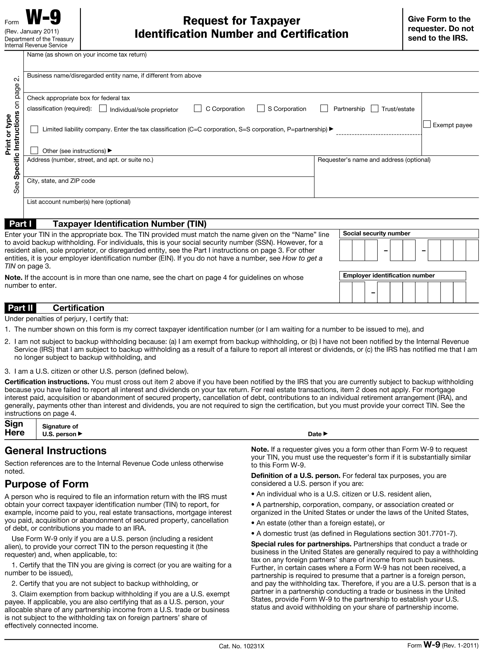

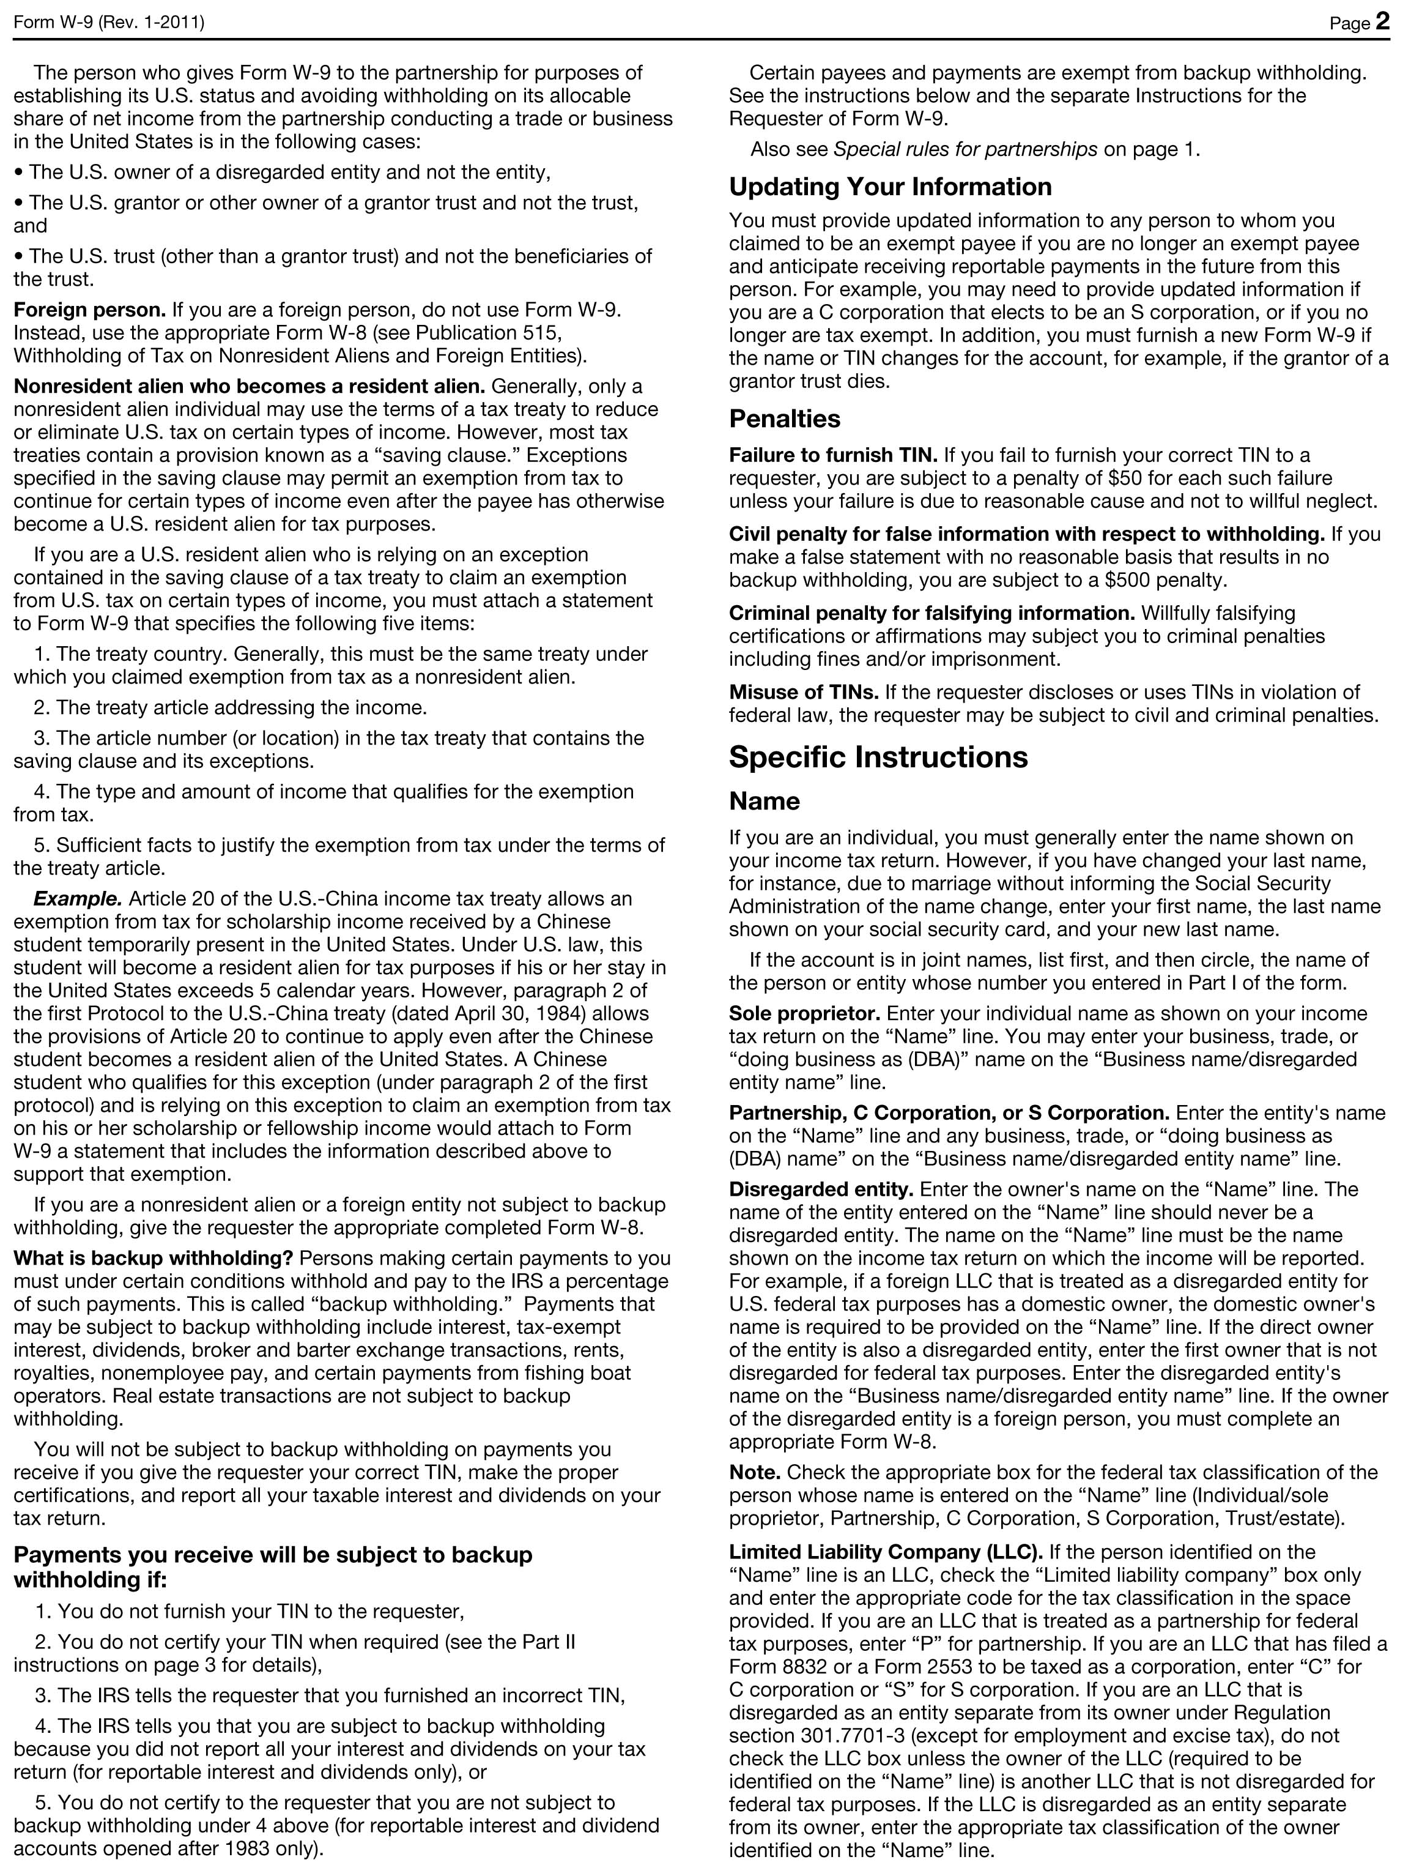

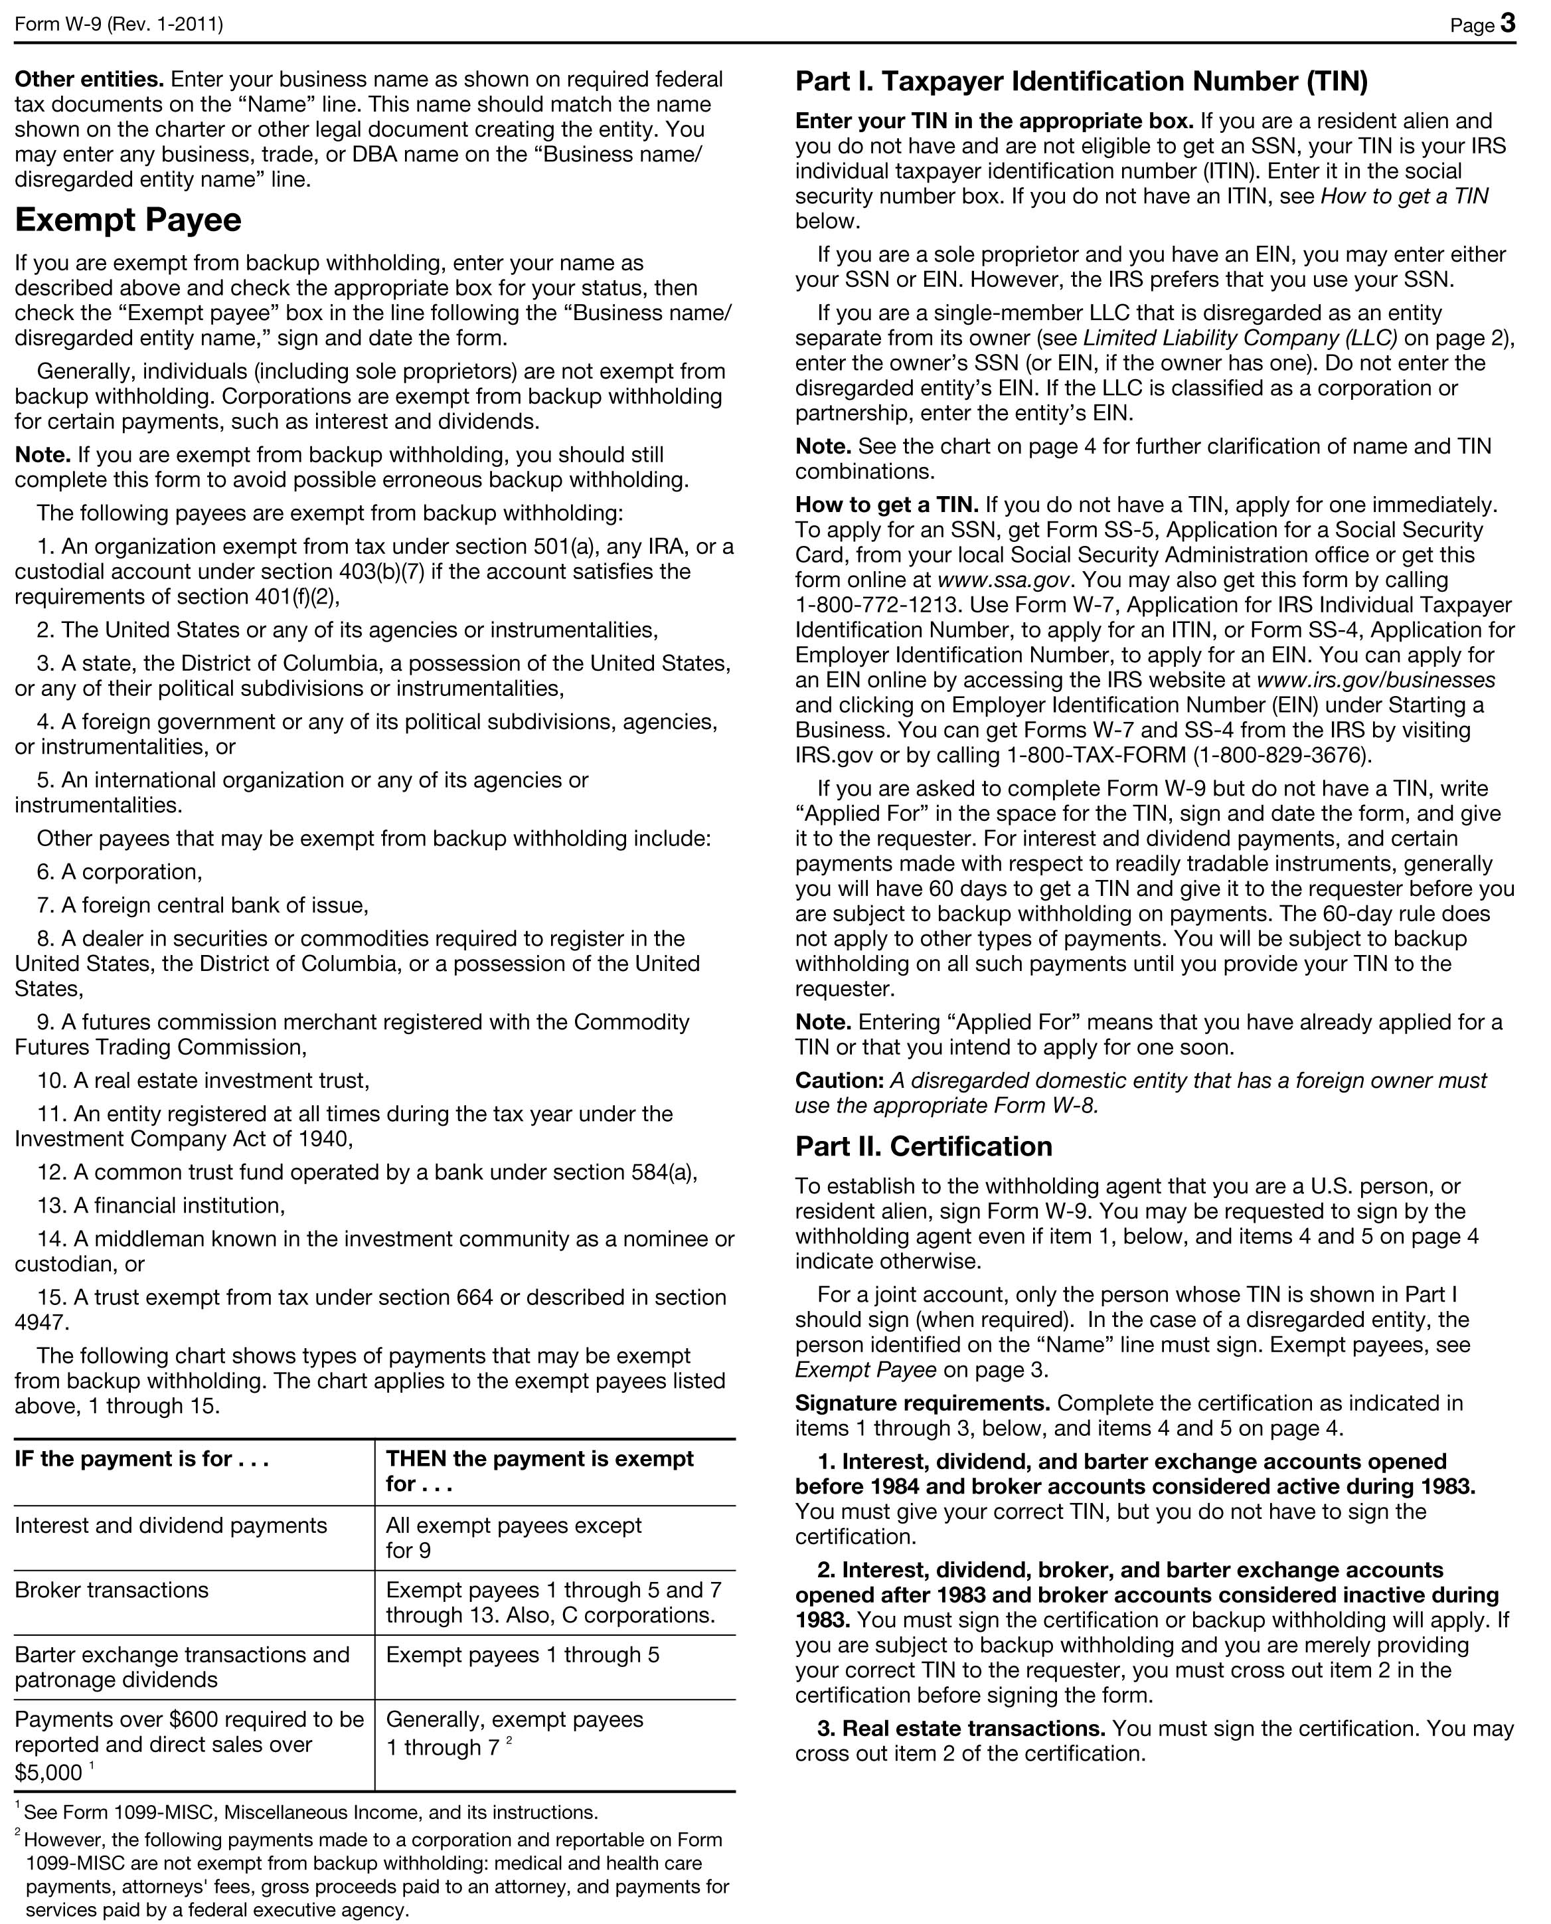

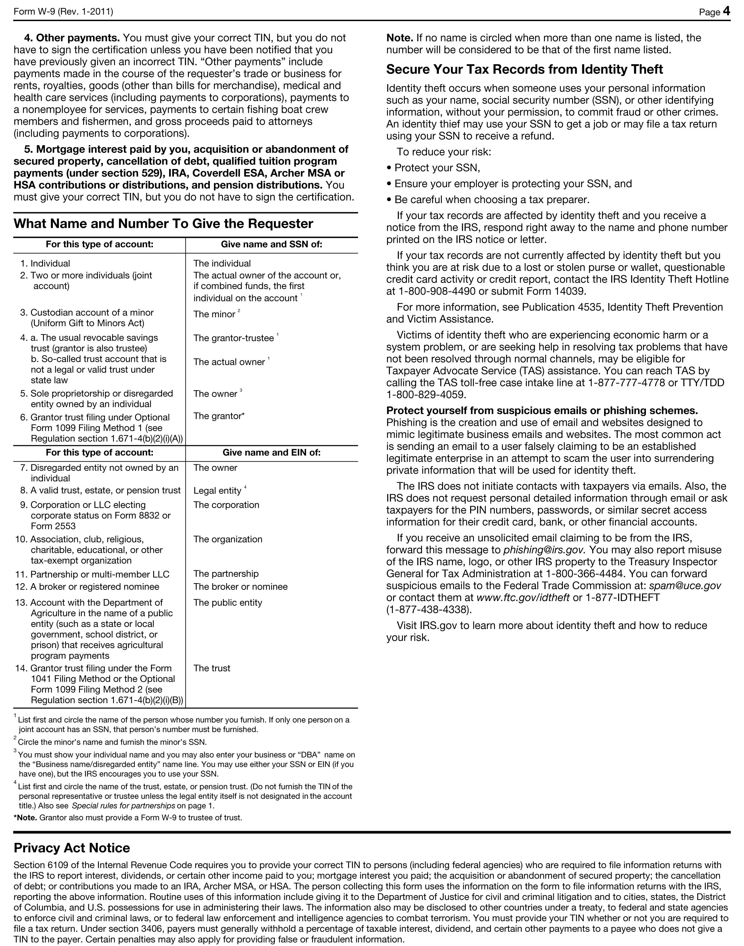
CERTIFIED LOCAL GOVERNMENT AUTHORIZED SIGNATORY
Signature: Date:

_________________________________________________________________ ______________________

The Grant Application Form must be signed and dated by the authorized contract signatory or another appropriate individual.
Printed Name and Title:
CLG Sponsorship (if applicable)

Signature: Date:

_________________________________________________________________ ______________________

The Grant Application Form must be signed and dated by the authorized contract signatory or another appropriate individual.
Printed Name and Title:
CHECKLIST
Attach the following Exhibits to complete the CLG grant application. Please refer to the CLG Grant Manual for instructions.

☐ Exhibit A: Financial Certification
☐ Exhibit B: Tax Incentive Certification
☐ Exhibit C: Deed and Ownership Information
☐ Exhibit D: Flood Plain Certification
☐ Exhibit E: Resolution
☐ Exhibit F: Grant Application Support Letters
☐ Exhibit G: Bylaws and Articles of Incorporation
☐ Exhibit H: Photographs
☐ Plans and specifications – Not applicable for Rehabilitation Planning Projects

Applications Due: Completed applications must be received and date stamped by the SHPO no later than 5:00 p.m. on October 1, 2019.

Send one original Certified Local Government Grant Application Form and Exhibits to:

Joelle Letts, Grants Manager/Budget Analyst
Michigan State Housing Development Authority
State Historic Preservation Office
735 East Michigan Avenue
P O Box 30044
Lansing, MI 48909-7544

Failure to submit a timely application or failure to provide all information requested above may result in your application not being scored.

