Optimize Main Street
Program Guide

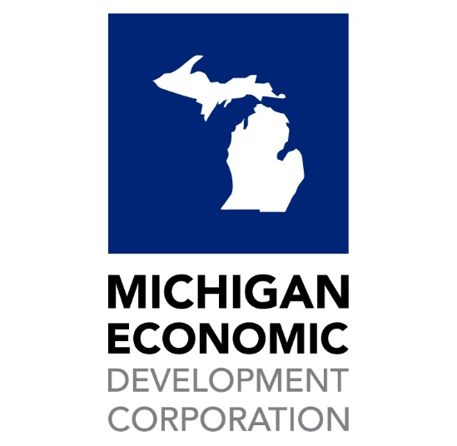

Program Description

Optimize Main Street is designed to support place-based businesses located in eligible Michigan communities, by providing technology-related technical assistance and grant funding. Through the increased technology expertise and use of digital tools, participating businesses will aim to refine efficiency in business operations, improve connectivity to customers, and/or increase sales. The Optimize Main Street program is implemented through a combination of one-on-one business coaching, a customized learning module, and a $2,500 for technology grant to support project implementation.

The Optimize Main Street program is open to a select number of Michigan communities, including: Michigan Main Street programs, Redevelopment Ready Communities designated as Essentials or Certified with a population of under 15,000, and/or non-profit business support organizations or community and economic development organizations who have previously participated in Initiate Business Retention Training. The Michigan Economic Development Corporation (MEDC) finds value in partnering with these select communities and organizations because these entities have demonstrated existing local capacity to support new and existing small businesses. Additionally, these entities have a proven track record of providing technical assistance, training, and education to place-based businesses within their respective main street-type districts.
The MEDC has partnered with Northern Initiatives (NI), a Michigan-based CDFI, to serve as the administrator of this program. Optimize Main Street builds upon the MEDC’s ongoing partnership with Northern Initiatives - which provides increased access to the robust small business learning portal called Initiate. In addition, Optimize Main Street is MEDC’s first small business financial incentive that ties grant dollars directly to technical assistance milestones.
Program Goals:
Optimize Main Street strives to:
- Support business resiliency and sustainability by increasing awareness and skills on technology and digital tools through blended learning, including training, 1-on-1 coaching, and self-paced learning modules.
- Provide funding to participating small businesses to support the implementation of a technology-related project that will lead to improved business operations, diversify sales channels, and/or attract new customers.
- Support Michigan’s entrepreneurial ecosystem by providing a small business retention and growth tool that eligible organizations can leverage to provide value to their small business customers
How the Optimize Main Street program works:
Each participating community will select up to two businesses to put forth for the Optimize Main Street program, based on the organization’s sole discretion and desired selection process. Once businesses are selected, the local applicant will complete the Optimize Main Street Application (Appendix A). Within the application, the sponsoring community/non-profit will list the business(es) within their district that they have selected to participate in the program. Prior to the Optimize Main Street Application being submitted, all participating businesses must complete an online Business Technology Assessment (Appendix B). The Business Technology Assessment is estimated to take 45 minutes to complete.
Once the application window closes, the MEDC will review applications in the order in which they were received. Applications and Business Technology Assessments will be reviewed to ensure selected businesses meet eligibility requirements. Once eligibility is determined, MEDC staff will contact selected businesses, notify them of program selection, and introduce them to their business coach at Northern Initiatives.
Due to the volume of businesses being supported with this program, businesses will be referred to Northern Initiatives in three rounds based on the order in which their applications were received. Eligible businesses put forth to participate in the Optimize Main Street program will be awarded on a first-come, first-serve basis until all available funding is allocated.
- First Round (June and July 2023) – 37 businesses
- Second Round (August and September 2023) – 37 businesses
- Third Round (September and October 2023) – 36 businesses
When the identified funding round for the awarded businesses arrives, the participating business will work directly with Northern Initiatives to complete the program requirements which must be completed within 45 days from notification of program selection.
Local Organizations Select Participating Businesses
Communities/non-profit entities that are eligible to apply and identify up to two businesses to participate in this program are listed in Appendix C: Timeline and Assignments. The selection of participating businesses is a local decision. Each community may set its own priorities for selection. Participating communities/non-profits will complete the required Application (Appendix A) prior to the deadline. Prior to the Optimize Main Street Application being submitted, all participating businesses must complete an online Business Technology Assessment (Appendix B). The Online Business Technology Assessment is estimated to take 45 minutes to complete.
Eligible businesses put forth to participate in the Optimize Main Street program will be awarded on a first-come, first-serve basis until all available funding is allocated.
Business Eligibility & Qualities
Each community will certify that the small businesses selected to participate in the program meet the following eligibility requirements:
- Have completed the online Business Technology Assessment via Google Forms (Appendix B)
- Have a physical location located within a dense, commercial corridor or traditional downtown district
- Are headquartered in Michigan
- Have a need for technology integration
- Are coachable and committed to completing the required technical assistance
- Can complete the minimum required coaching and technical assistance within 45 days of application award notification

Small Businesses Begin Working with Northern Initiatives
Following the application submission by the sponsoring community/entity, the MEDC will review applications to ensure selected businesses meet eligibility requirements. Once eligibility is determined, MEDC staff will contact selected businesses, notify them of program selection, and introduce them to their business coach at Northern Initiatives.
Due to the volume of businesses being supported with this program, businesses will be referred to Northern Initiatives in three rounds based on the order in which their applications were received. Eligible businesses put forth to participate in the Optimize Main Street program will be awarded on a first-come, first-serve basis until all available funding is allocated.
- First Round (June and July 2023) – 37 businesses
- Second Round (August and September 2023) – 37 businesses
- Third Round (September and October 2023) – 36 businesses
When the identified funding round for the awarded businesses arrives, the participating business will work directly with Northern Initiatives to complete the program requirements which must be completed within 45 days from notification of program selection.
What are the requirements for a participating small business?
Each business will work directly with Northern Initiatives to complete the program requirements, which must be completed within 45 days from notification of program selection. Businesses will be required to complete the following steps in the order listed below:
- Step 1: The business will schedule and attend a 1:1 initial coaching session with a Northern Initiatives (NI) Business Coach. During this session, Northern Initiatives will go over the Business’s technology assessment and discuss recommended resources via the Initiate platform
- Step 2: Business receives and completes a customized learning module through Initiate.
- Step 3: Upon completion of Step 2, the business will schedule and attend a 1:1 follow-up meeting with a Northern Initiatives business coach. During this session, the business owner will review the modules with the NI coach and discuss how the technology grant will be used.
- Step 4: After the 1:1 follow-up meeting, Northern Initiatives will perform a final verification that program requirements have been met & will process the grant disbursement request. During this time, the business will implement the project within the 45-day compliance period.
- Step 5: By participating in the Optimize Main Street Program, businesses will commit to completing the post-program survey, which will be distributed via email by Northern Initiatives 90 days after program participation.

How will grant funds be disbursed?
The Optimize Main Street program will provide small businesses $2,500 in grant support following the successful completion of program requirements. At the final one-on-one coaching session, the business and the NI Business Coach will identify how the business will use the grant funds. Awarded grant funds – in most cases – will need to be reportable on IRS Form 1099.
What eligible expenses may be covered with grant funding from the Optimize Main Street program?
Grants will be awarded in the amount of $2,500 per eligible business. Grants may be used by eligible businesses who successfully complete all program requirements. Funds may be used to purchase hardware, software, or third-party contract services that will incorporate or advance the usage of technology within the business to increase efficiency in business operations, improve connectivity to customers and/or increase sales.
Examples of eligible expenses include:
- Hardware – computer, laptop, tablet, modem, WiFi equipment, printer, point of sale system, camera, lightbox, or similar equipment to advance technology operations for the business
- Software –website development including domain name, web hosting and/or e-commerce integration, web platform subscriptions including QuickBooks, point of sale, printing, graphic design, content management, email marketing, or similar platforms
- Contract Services from a third party – grantee may work with a small business or third-party contractor that has expertise to help grantee meet technology goals, ex. mobile optimization, social media content calendar creation, SEO, email marketing, etc.
Grant funds may not be used for advertising expenses, lead generation (such as online advertisements, paper advertisements, and/or purchasing customer lists), or other expenses deemed unacceptable to the MEDC. Funds may not be used prior expenses incurred.The Business will work directly with the Northern Initiatives Business Coach to identify eligible use of funds and estimated costs prior to funds being disbursed.
Program Launch & Timing
The application and selection of Optimize Main Street participants will follow the timeline outlined below.
April 7, 2023 | Program Announced
May 1, 2023 | Application Window Opens
June 1, 2023 | Application Window Closes
Week of June 12-16, 2023 | Small Businesses notified of their selection & program participation begins
Fall 2023 | All technical assistance is complete and grant dollars deployed
Ongoing | Post-Program Check-In Survey sent to participating businesses 90 days after program participation

