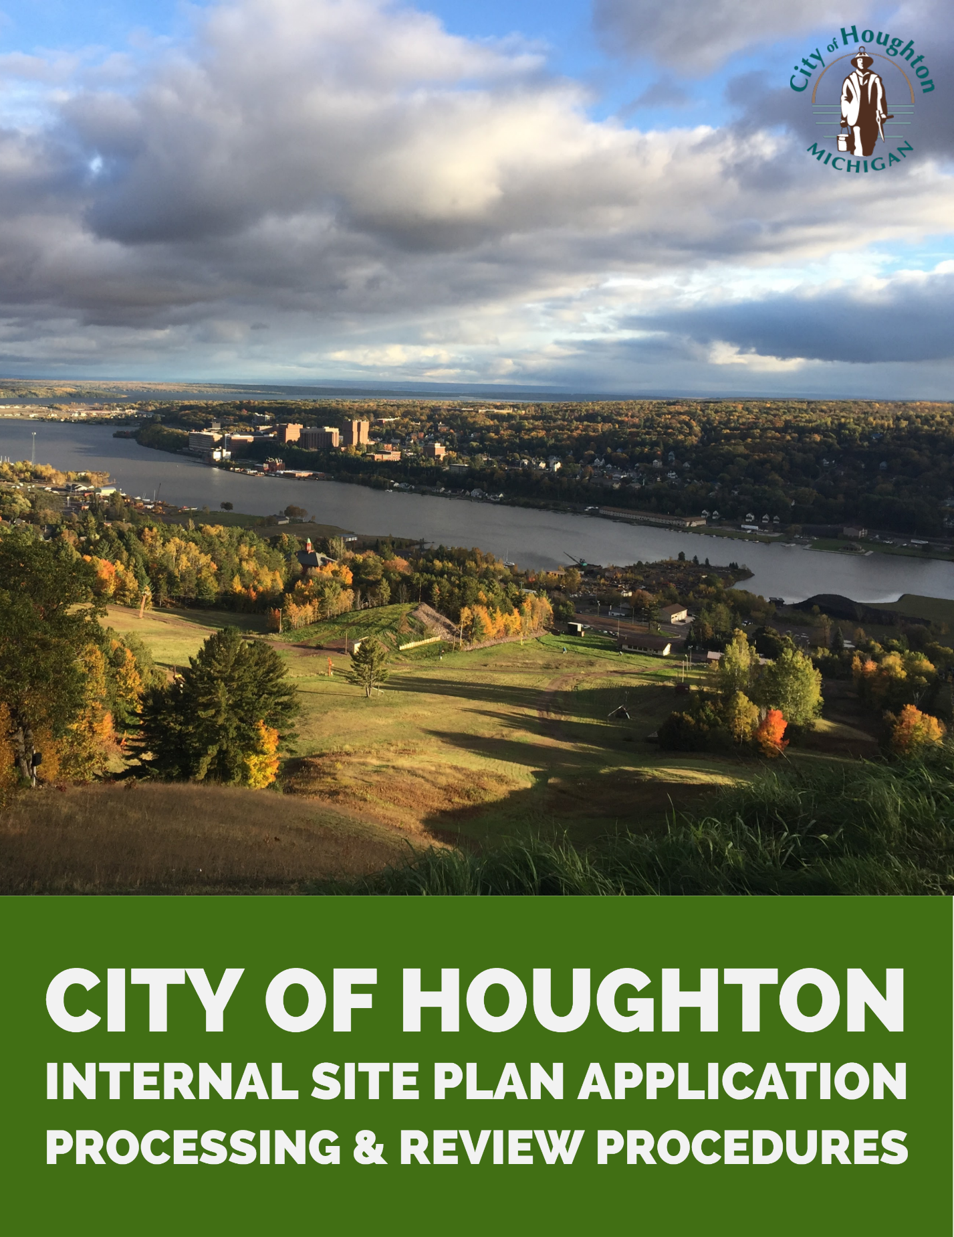

2019

This guide was prepared by the Western Upper Peninsula Planning & Development Region Commission (WUPPDR) with support from city staff and financial support from the Michigan Economic Development Corporation’s (MEDC) Redevelopment Ready Communities (RRC) Program.

Application Processing

Completeness Review
- Applicant meets with the Code Enforcement Officer for a Conceptual Review Meeting prior to application submission. The applicant should bring the completed zoning permit application and preliminary plans to the meeting. Any edits and comments should be provided.
- Once application is officially submitted (21 days prior to a Planning Commission Meeting), ensure that the application has a full copy of all application requirements.
- The Code Enforcement Officer and City Manager will review the application once more and provide edits, if needed. If application is not complete, notify applicant. If complete, the Officer will create a paper file and electronic file for the application (see below).

File Creation
- Create a manila folder for the case and label with the property identification number and associated permit number. Permit number should indicate the year and application number for the year. For example, #19-001 (19 indicates the year, 2019, and 001 indicates that it is the first file received).
  - A tax identification number is also assigned to the file.
- Scan all application documents and save to electronic case folder.
  - Electronic case folders are organized by permit number for a particular year.

Application Routing
If other departments are impacted by the application, they should be notified via direct communication.

Public Hearing Notices
- All Planning Commission requests for Rezoning require Public Hearing notices to be published in the Daily Mining Gazette and mailed to all owners and occupants of properties located within 300 feet of the subject parcel(s). Notices must also be placed on the city website (www.cityofhoughton.com).
- Notices must be published in the newspaper at least 15 days prior to the hearing. The Public Hearing notice is e-mailed to the Gazette (jsorensen@mininggazette.com) in Word format and faxed to 482-2726 three days before the date it needs to be published.
- Ask the Gazette on the notice to provide an Affidavit of Publication. An e-mail will be received with a proof of the notice; review and respond.
- On the same day as sending the notice to the Gazette, mail the notices to owners and occupants.
- Site Plan Reviews do not require Public Hearing notices.

Preparing the mailing lists
- Use the city zoning map to determine which properties need a notice. Set a compass to 1 ½ inches (one inch = 200 feet) and draw a circle in pencil around the parcel(s). Write down the parcel numbers of the properties that need a notice.
- If a parcel has tenants, the tenants also need to be notified. If there are more than four (4) leased units in a parcel, the owner or manager can be sent the notice with instructions for them to post the notice at a primary entrance to the structure.
- Go to BSA tax program. Under parcel list, mark the parcels that need a notice and choose the field “marked parcels.” Then print a Zoning Parcel List and mailing labels. For the tenants, you can write their names and addresses on an envelope as well as the parcel list for our records.
- Attach a mailing label to an envelope, insert a notice in each envelope, and mail them out.
- Keep a copy of the Public Hearing notice, notice to the Gazette, Zoning Parcel list, and Affidavit of Publication when received with the minutes of the public meeting.

Preparing public hearing notice
- Open public hearing notice template located in Documents/Public Hearings/Template
- Update the notice with the appropriate meeting date, case number, address, application name, case description, property legal description, and publication date.
- Review the notice for accuracy and completeness.
- Save the public hearing notice in the Documents/Public Hearings folder under the appropriate year.

Placing notice on City website
- Make a copy of the public notice from Word.
- Go to www.cityofhoughton.com/control. Type in username and password.
- Under “Public Hearing Notices,” select “add.” Type in the date of the hearing and paste the copied information into the screen. Select “save” to publish the notice.

Submitting for publishing
- Email jsorensen@mininggazette.com with the following message and attach a Word copy of the notice:
SUBJECT: Notice of Public Hearing
DATE: [date sent]

Please publish the attached notice of public hearing in the [INSERT DATE YOU WANT IT PUBLISHED] edition, and please furnish an affidavit of publication.

Please send the affidavit to my attention at City of Houghton, City Center, P.O. Box 606, Houghton, MI 49931.

Thank you! If you have any questions, please call me as soon as possible at 482-1700.

- Also fax a copy of the notice to the Daily Mining Gazette at 482-2726.
- They will send back a copy to proof along with the price.
- Once you verify it is correct, confirm via email or phone (482-1500) that it is okay to publish.
- Once you receive the affidavit back, attach it to the minutes of the meeting for the public hearing in the minutes book.

Preparing the mailing lists
- Print one copy of the public hearing notice for each recipient.
- Print mailing labels for the owners and occupant lists using the BSA software tax program.
- Trifold each notice and insert into a standard City letter envelope.
- For properties that contain more than four units or leased areas such as apartment complexes, notice can be given to the manager or owner, who is then required to post the notice at the primary entrance to the structure or whatever other means accomplishes the task.
- Prepare the public hearing notice affidavit.
  - Open the template located in Documents/Public Hearings/Affidavit Template folder.
  - Update the template with the correct case number and date.
  - Attach a copy of the notice map and mailing addresses to the affidavit.
  - Have the affidavit notarized.
  - Place the affidavit and attachments in the paper case folder.

Additional public notification outlets
- Post the notice on the public hearing section on the City website
- Post the notice in the front window of City Center

Application Review

Staff Review
- Review the application package for conformance with the following Site Plan Review standards:
  - Section 98-600 – Site Plan Review
  - Section 98-203 – Landscaping requirements
- Visit site under consideration
  - If the project involves a public hearing, this visit should occur at least 15 days prior to the public hearing and a “NOTICE OF PUBLIC HEARING” sign(s) shall be posted on site in accordance with the guidelines adopted by the Planning Commissions, which are available in Documents/Public Hearings/Year.
  - For all site visits, photographs are taken for use in the staff report and subsequent presentations to the Planning Commission.
- Identify any missing, incomplete, or inaccurate information.
- Identify any issues with conformity to City standards.

Application Review Meeting
The Site Plan Review Team will meet the Tuesday before the Planning Commission meeting to discuss preliminary comments. The meeting focuses on ensuring the consistency of staff comments to the application prior to finalization of the staff report and Planning Commission Packet.

Initial Feedback to Applicant
Any missing, incomplete, or inaccurate information; clarification questions; or issues of conformance with the zoning ordinance are shared with the applicant, typically one week before prior to the finalization of the staff report and typically in writing via email. The applicant may decide at his time to submit additional information or postpone consideration of the application until a later date. Continual verbal or electronic communication should be maintained with the applicant.

Staff Reports
A staff report will be prepared for each case that goes before the Planning Commission. The staff report is prepared by the City Planner. The staff report template is available in the PLN>Planning Commission folder.

Attachments to the staff report typically include a copy of the application; a copy of the site plan (if required); a copy of any building plans or elevations; and a copy of comments from other applicable departments.

Copies of comments from other applicable departments are received via email. The comments are saved in both the electronic and paper case files.

Packets
Upon completion of the staff reports (generally one week before the meeting date) the meeting packet is prepared by planning staff for the Planning Commission and distributed to the parties below. The report includes the following:
- Site Plan application and review checklist
- Create a general memo with extra pertinent information that is not on the application

Hard copies of the packet are delivered by planning staff to the following:
- Planning Commission (9 copies)

Hard copies of the packet are placed by planning staff:
- In the Planning Commission packet notebook for that year.

Electronic copies of the packet are sent via email to the following groups and individuals:
- Planning Commission
- City Manager
- Building Official
- Fire Marshall

Electronic copies of the agenda and relevant staff reports are sent to each applicant via email.

A hard copy of the staff report is included in the paper case file.

An electronic copy of the packet is also saved in the Documents/Ann/Ameriscan/Year/(saved by date of meeting) and posted on the City website.

Application Finalization
Following consideration of the application by the Planning Commission (or, in the case of administrative reviews, staff), if there are any further questions about the application, the applicant or a representative should be present at the meeting to answer these inquiries. A decision should be made at the meeting. Below are the typical scenarios for the application:
- Approved as submitted. The application is approved without conditions. If a site plan is connected to the application, a stamped and signed copy of the site plan is attached to the letter.
- Approved subject to conditions. The application is approved with conditions which are listed in and/or attached to the letter.
  - If a site plan is connected to the application, a stamped and signed copy of the site plan is attached to the letter ONLY if the conditions of approval do not include modifications to the site plan.
  - If site plan modifications are needed, the first letter will indicate that the applicant must submit an updated site plan meeting those conditions to receive final approval. Upon receipt of a site plan meeting those conditions, a second letter indicating final approval is sent with a stamped and signed copy of the final site plan.
- Postponed. The Planning Commission, the applicant, or staff has postponed action on the application. An explanation of next steps is included in the letter.
- Denied. The Planning Commission or staff has denied the application. Reasons for denial are outlined in the letter along with information about appeal of that decision.
All letters are distributed in the following ways:
- Electronic copy to the electronic case file.
- Electronic copy attached to the property record in BS&A.
- Hard copy to the paper case file.
Store the paper case file in the property files (sorted by parcel identification number).

For Rezoning cases only (if approved)
The following items are provided to the City Manager via email for inclusion in the agenda packet for the next City Council meeting:
- A cover memo is prepared by planning staff indicating the recommendation made by the Planning Commission regarding the application. The memo will indicate a request that the City Council set a public hearing on the item.
- A copy of the application package
- A copy of the Planning Commission staff report
- An excerpt of the draft Planning Commission minutes related to the application.

