Build Excitement with a Communication Plan
An effective communication plan is essential to keeping your project top-of-mind in the weeks leading up to your event. With a solid plan, you can promote your event, project and business.

Tell Your Story
An interesting story will help people connect with your project more meaningfully. Stories capture people’s attention and help them remember your important place in the community.
When telling your story, remember that your community is a main character. Outline the needs of your community’s people and businesses, then with each post on social media or a blog, explain how this project helps solve existing challenges.

Keep It Simple
Whatever you publish, keep it focused on a simple idea and make it easy to read. Not every aspect needs to be a polished advertisement; people like to see stories about humans by humans.

Know What to Present
Make the most of your content, and don’t be afraid to use it in multiple places. LinkedIn, Facebook and Twitter might all reach different people, and blog posts can be another great way to use the pictures and quotes you collect.
- Event-centric: Speak directly about the event, including the time and place.
- Storytelling: Highlight the community’s needs and reference how your project will help keep the area vibrant.
- Profiles: Speak with community members, local leaders and partners for quotes that make for simple but interesting content.
When you do reference the event, be sure to include the right things:
- Provide the date of your event
- Spell out the activities taking place at your event
- Announce speakers and special guests
- Use hashtags, both your own and those used by your partners
- Include eye-catching photos to draw attention to your content

Use Different Mediums
There are many ways to get your message out into the community, and you can use them in concert:
- Website pages and blogs
- Social media
- Partner newsletters
- Business association periodicals
- Newspapers
Reach out to your development partners and the local Chamber of Commerce to see if they’d be willing to run a story related to your event. Submit your press release to the local newspaper and community editions. Post the event plan to your website and link to it from your social posts.

Take Great Pictures
There are all kinds of different pictures you can take that will help your stories and posts catch the eyes of the right audience. Faces and active people stand out more for those that are scrolling on social media. It’s also important to remember to pay close attention to what’s in the frame and the lighting in the shot.

Shape Your Content Calendar
Develop a schedule early. A proactive approach will help you plan your posting cadence, track which posts are successful and show you where to reuse content.
Four weeks out:
- Define your messaging and draft your press release.
- Use this messaging to post an event announcement on your website and social media.
- Contact partners to see where you can place your long-form, community-impact stories.
- Start slow with one or two social posts this week and gradually increase the pace.
Three weeks out:
- Send out your press release and event invites.
- Commit to two more social posts this week.
- These posts should include one storytelling or profile post that focuses on the community impact while referencing your event.
Two weeks out:
- Refresh your webpage with event updates and mentions in the local newspaper.
- Commit two social posts to the event and a third to building community recognition. This type of content will help keep people interested well after the event.
One week out:
- Post three more times this week to help excitement reach its peak.
- Repost a successful story, link to an online newspaper article and highlight your event with a combination of storytelling, profiles, quotes and event reminders.
- Provide your event to another newsletter so no one misses the big event right around the corner.
The day of the event:
- Post throughout the day, sharing speakers, tours and other candid photos and quotes.
After the event:
- Continue telling the community what a success the event was at your own pace.
- As long as people are still engaging with your posts with comments, it’s a good way to remind the community of what you have to offer.

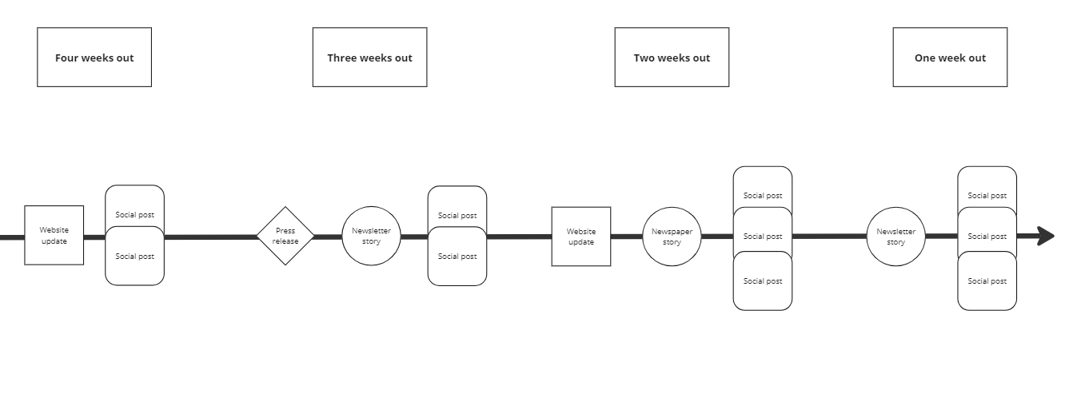
Potential examples:
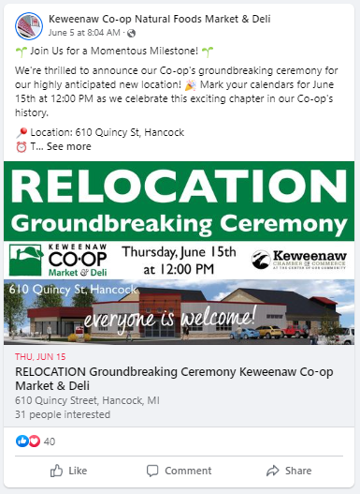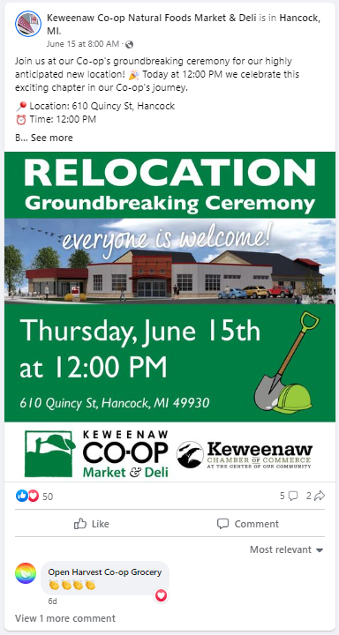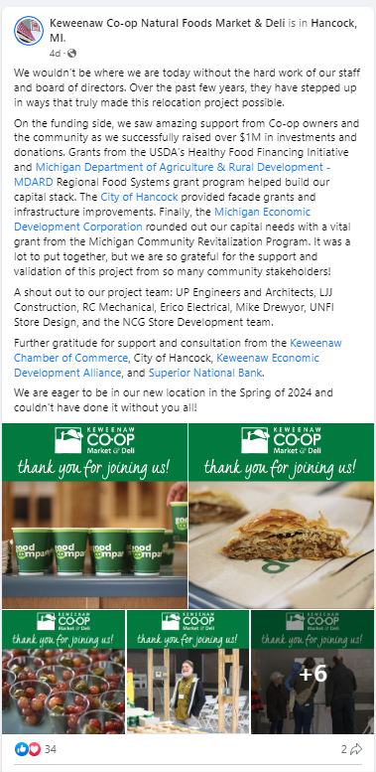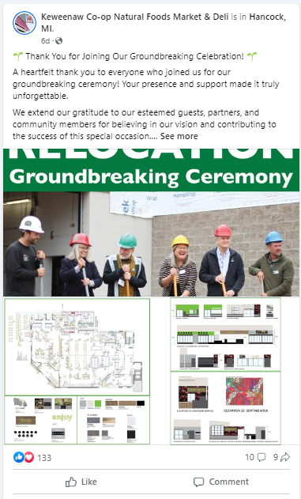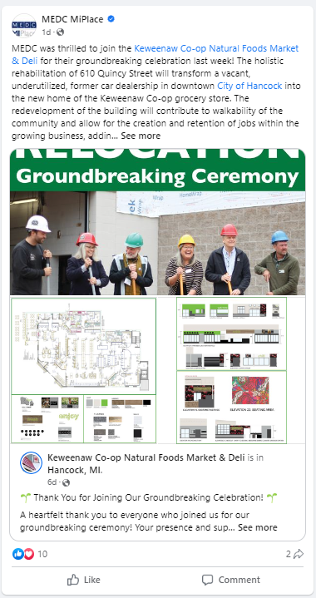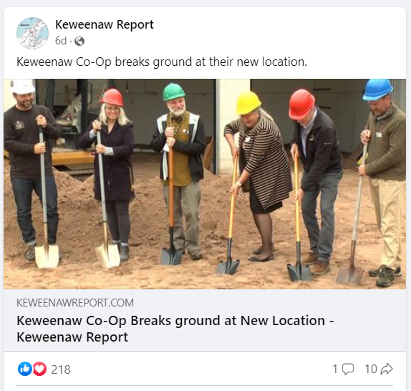
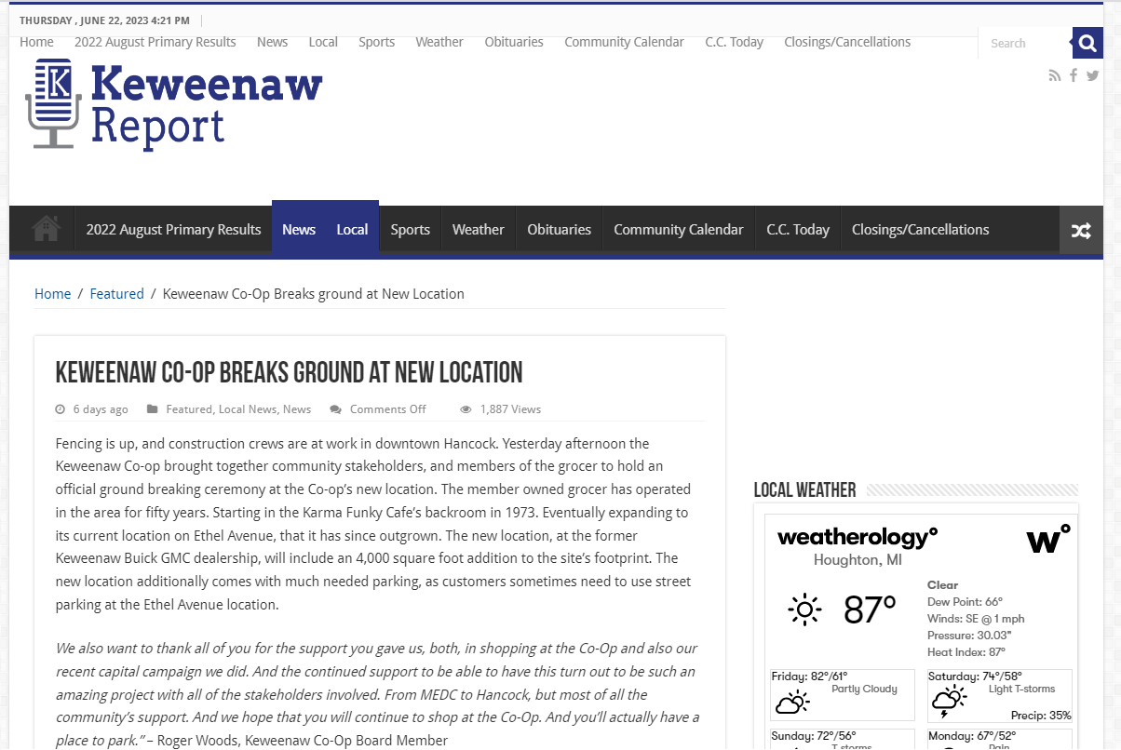
http://www.keweenawreport.com/featured/keweenaw-co-op-breaks-ground-at-new-location/

